Lifetime Tester
User Manual
Document ID: 23-10-051-VTF-CBAIC-UM
Rev.: 1.0
Captronics Systems Pvt Ltd
 | Name | Signature | Date
Prepared By | Ananth A
Reviewed By | Prabhakaran T J
Approval By | Midhunseelan O S

Customer
 | Name | Signature | Date
Reviewed By | Abhay Kumar |  | 14.02.2025
Approved By

Document ID | 23-10-051-VTF-CBAIC-UM
Document Name: | User Manual
Document No.: | R/PP-03/25
Project/Product Name: | Lifetime Tester
Project/Product Code: | 23-10-051-VTF-CBAIC
Revision Status: | 1.0

Change Summary

Release No. | Date | Changed By | Change Description
Version 1.0 | 03-02-2025 | Ananth A | Initial Version

Table of Contents
Change Summary 2
Table of Contents 3
List of Tables 7
List of Figures 7
Terms, Definitions and Abbreviations 10
1 Safety Precautions 11
2 Normal service conditions 11
3 Installation Instructions 12
4 Introduction 12
5 Scope 12
6 Tools Overview 13
7 Tools Specifications 13
7.1 Functional Specifications 13
7.2 Non-Functional Specifications 15
7.3 Compliance Specifications 15
8 Pictorial View of 6 Head Lifetime Tester 16
8.1 6 Head LTT Instrument Rack. 16
8.2 Lifetime Tester Power supply Rack 17
9 Pictorial View of 3 Head Lifetime Tester. 18
9.1 3 Head LTT Instrument Rack. 18
9.2 3 Head LTT Power supply Rack and RL Load. 19
10 Procedure to Power ON Console 20
10.1 Prior Inspection 20
10.2 Turn ON the Main Switch 22
10.2.1 Turn ON the Main Toggle Switch 22
10.2.2 Verifying the ON the Three Phase Indicator 22
10.2.3 Turn ON the Rig Push Button Switch 23
10.2.4 Ensure the Turn ON the MCB. 23
10.2.5 Ensure the Turn ON the PXI. 24
10.2.6 Turn ON the UPS Switch 25
10.2.7 Turn ON the Low Voltage PPS Switch 25
10.2.8 Turn ON the Power Supply Rack 26
10.2.9 Turn ON the High Voltage PPS Switch 26
11 Software Details 27
11.1 How to Launch LTT Application 27
11.2 User Interface Flow 27
11.3 Main Screen 28
11.4 How to Login and Manage Users 29
11.4.1 Login Procedure 29
11.4.2 Creating a New User 30
11.4.3 Change User / Admin Password 31
11.4.4 Delete Username from List 32
11.4.5 Find Username from List 33
11.5 Procedure to Change System Configuration 34
11.5.1 Procedure for Import data to change existing configuration 35
11.5.2 Procedure Export data in .csv file 36
11.5.3 Procedure the Setting Screen Update. 37
11.5.4 Procedure the Setting DAQ Configuration Screen Update. 38
11.5.5 Procedure the Select the DUT ID and Channel Type Screen Update. 39
11.5.6 Procedure the Double Click the Select the Specfic Row Signals. 40
11.5.7 Procedure the Update Signal Name and Enable and Disable Option. 41
11.5.8 Procedure the Setting Screen - Refresh the DAQ Configuration. 42
11.6 Procedure for Auto Mode (To Start New/Existing Test) 43
11.6.1 Auto Mode Details Screen 44
11.6.2 Sequence File Loading and Start the Test. 45
11.6.3 Number of Socket Entry 46
11.6.4 Serial Number Entry Screen 47
11.6.5 Test Selection on Screen(New Test/ Resume test) 48
11.6.6 New Test 49
11.6.7 Continuous/Resume Test 50
11.6.8 Verify Sequence Running 51
11.6.9 Verify Wait Monitor step while a mode is running. 52
11.6.10 Procedure for Terminating a Test 53
11.6.10.1 Verify Test Termination Completion. 54
11.6.11 Procedure Stop the Test in case of any Error 55
11.6.12 Procedure for Exiting the Application. 56
11.8 Diagnostic test screen 57
11.8.1 Digital Input Diagnostic Screen 58
11.8.2 Digital Output Diagnostic Screen 59
11.8.3 Relay Output Diagnostic Screen 60
11.8.4 Analog Input Diagnostic Screen 61
11.8.5 Analog Output Diagnostics Screen 62
11.8.6 PWM Input Diagnostics Screen 63
11.8.7 PWM Output Diagnostics Screen 64
11.8.8 CAN Diagnostics Screen 65
11.8.8.1 Check VAL Software and Mode Testing 66
11.8.8.2 Read FE FF Frames Data 67
11.8.8.3 CAN STP Generic Request/Response 68
11.8.8.4 Monitor CAN Log 69
11.8.9 High Voltage PPS Diagnostic Screen 70
11.8.9.1 HV PPS Initialization 70
11.8.9.2 HV PPS Self-test 71
11.8.9.3 HV PPS Configure 72
11.8.9.4 HV PPS Measure Current 73
11.8.9.5 HV PPS Close 74
11.8.10 Procedure LV PPS Diagnostic Screen 75
11.8.10.1 LV PPS Initialization 75
11.8.10.2 Procedure LV PPS Self-test 76
11.8.10.3 Procedure LV PPS Configure 77
11.8.10.4 Procedure Configure LV PPS Measure Current 78
11.8.10.5 Procedure LV PPS Close 79
11.9 Temperature Diagnostic Screen 80
12 Procedure for Flashing of VAL Software to DUT 81
12.1 Setup 81
12.2 Procedure for Manually Flashing of VAL Software to DUT 82
12.2.1 Procedure of DUT Power ON. 83
12.2.2 Turn ON Power Supply (T30 and DC Link) 84
12.2.2.1 High Voltage PPS Initialize 85
12.2.2.2 High Voltage PPS Configure 86
12.2.2.3 Turn ON High Voltage PPS Digital Output(Relay) 87
12.2.2.4 Low Voltage PPS Initialize 88
12.2.2.5 Low Voltage PPS Configure 89
12.2.2.6 Turn ON Low Voltage PPS Relay Output 90
12.2.3 CAN Configure 91
12.2.3.1 Read SW Version 92
12.2.4 Flashing New Software 93
12.2.5 Verify Updated SW after Flash 93
12.3 Procedure for Automated Flashing of VAL Software to DUT 93
12.3.1 Run the Software Flash Sequence 93
12.3.2 Read existing software 94
12.3.3 Flashing New Software 95
12.3.4 Reboot DUT 96
12.3.5 Verify New Software 97

List of Tables
Table 1: Terms, Definitions and Abbreviations 10
Table 2: Functional Specifications 13
Table 3: Non-Functional Specifications 15
Table 4: Compliance Specifications 15

List of Figures
Figure 1: Lifetime Tester. 16
Figure 2: Lifetime Tester Power supply Rack. 17
Figure 3: 3 Head Lifetime Tester. 18
Figure 4: 3 Head Lifetime Tester Power supply Rack and RL Load. 19
Figure 5: NI MAX Card Information 20
Figure 6: Main Power Switch 22
Figure 7: RYB Power ON Indicator 22
Figure 8: Rig ON/OFF Push Buttons 23
Figure 9: MCB ON Condition 23
Figure 10: PXI ON Indication 24
Figure 11: UPS On Indication 25
Figure 12: Low Voltage PPS On Indication 25
Figure 13: High Voltage PPS On Indication 26
Figure 14: Lifetime Tester Splash Screen 27
Figure 15: User Interface Flow 27
Figure 16: Main Screen 28
Figure 17: Login Panel 29
Figure 18: Add User Screen 30
Figure 19: Change User / Admin password 31
Figure 20: Delete username from the list. 32
Figure 21: Find username from the list. 33
Figure 22: Settings Screen 34
Figure 23: Setting Import Data 35
Figure 24: Settings Export Data 36
Figure 25: Settings Screen Update View 37
Figure 26: DAQ Configuration Settings Screen Update View 38
Figure 27: Select DUT ID and Channel Type Update View 39
Figure 28: Select the Row Signals Update View 40
Figure 29: Settings Screen Update View 41
Figure 30: Refresh the DAQ Configuration 42
Figure 31: Auto Mode and Login Test Screen 43
Figure 32: Auto Mode Screen User Interface Information 44
Figure 33: Sequence File Loading and Start Test 45
Figure 34: No of Socket Entry 46
Figure 35: Serial number entry 47
Figure 36: Test selection 48
Figure 37: New Test UUT Test Info 49
Figure 38: Continuous Test Selection 50
Figure 39: Sequence Running 51
Figure 40: Wait Monitor 52
Figure 41: Test Terminate 53
Figure 42: Test Terminate Completed 54
Figure 43: Error Handle 55
Figure 44: How to Exit Application 56
Figure 45: Diagnostic Test Screen 57
Figure 46: Digital Input 58
Figure 47: Digital Output 59
Figure 48: Relay Output 60
Figure 49: Analog Input 61
Figure 50: Analog Output 62
Figure 51: PWM Input 63
Figure 52: PWM Output 64
Figure 53: CAN Configuration 65
Figure 54: Test Software and Mode Write and eDCU Response Read 66
Figure 55: CAN Verify FE FF Frame Read 67
Figure 56: CAN STP Generic Read 68
Figure 57: CAN Log Read 69
Figure 58: HV PPS Initialize 70
Figure 59: HV PPS Self-Test 71
Figure 60: HV PPS Configure 72
Figure 61: HV PPS Measure Current 73
Figure 62: HV PPS Close 74
Figure 63: LV PPS Initialize 75
Figure 64: LV PPS Self-Test 76
Figure 65: LV PPS Configure 77
Figure 66: LV PPS Measure Current 78
Figure 67: LV PPS Close 79
Figure 68: Temperature control 80
Figure 69: Diagnosis mode Flash 82
Figure 70: Power Supply Selection 84
Figure 71: HV PPS Initialize 85
Figure 72: HV PPS Configure 86
Figure 73: HV PPS Relay Output 87
Figure 74: LV PPS Initialize 88
Figure 75: LV PPS Configure 89
Figure 76: LV PPS Relay Output 90
Figure 77: CAN Configuration 91
Figure 78: CAN Test VAL Modes 92
Figure 79: How to Flash Sequence 94
Figure 80: Existing Software version Read 94
Figure 81: Proceed Flash the Software 95
Figure 82: Reboot the Test 96
Figure 83: New Software Version Read 97

Terms, Definitions and Abbreviations
Table 1: Terms, Definitions and Abbreviations
Sl. No | Term | Explanation
1 | ATE | Automated Test Equipment
2 | UM | User Manual
3 | BOM | Bill of Materials
4 | UUT | Unit Under Test
5 | DUT | Device Under Test
6 | ITA | Interchangeable Technology Adapter
7 | HOST | The Server computer used as a controller for the system
8 | Platform | Phoenix Based Equipment Rack
9 | CSPL | Captronic Systems Pvt. Ltd.
10 | DAS | Data Acquisition System
11 | GUI | Graphical User Interface
12 | H/W | Hardware
13 | LabVIEW | Laboratory Virtual Instrumentation Engineering Workbench
14 | NI | National Instruments
15 | PXI | PCI Extension for Instrumentation
16 | PXIe | PXI Express
17 | NI Matrix | National Instruments Matrix
18 | PK Matrix | Pickering Matrix
19 | DI | Digital Input
20 | AI | Analog Input
21 | DO | Digital Output
22 | AO | Analog Output
23 | CAN | Controller Area Network
24 | FGEN | Function Generator
25 | Scope | Oscilloscope
26 | DC | Direct Current
27 | DMM | Digital Multimeter
28 | DIO | Digital Input and Output
29 | MIO | Multifunction Input and Output
30 | Calib | Calibration
31 | BOB | Brake Out Box
32 | OVP/OCP | Over Voltage Protection/ Over Current Protection

Safety Precautions

(Always read these instructions before using this equipment)
For personnel and product safety please read the contents of these operating instructions carefully before using. Please save this manual to make it accessible when required and always forward it to the end user.
 Indicates that the incorrect handling may cause hazardous conditions. Always follow the instructions because they are important to personal safety. Otherwise, it could result in electric shock, fire, erroneous operation, and damage of the instrument.

Normal service conditions


Use the instrument in an environment that meets the Normal service conditions as following points:
● Ambient temperature: -5 to 50°C, average day temperature: 35°C or lower
●Humidity: 30~85%RH, non-condensing.
●Altitude: 1000m or less
●Pollution Degree: 2
● Atmosphere without corrosive gas, dust, salt, oil mist.
●A place without excessive shocks or vibration.
● Do not expose to rain and water drips.
● An area where no pieces of metal and no inductive substances disperse.
● Do not expose to strong electromagnetic field and ambient noises.

Installation Instructions


This instrument should be installed and used by a qualified electrician.
● Verify the following points.

- Ratings Voltage 220-240 V AC phase-neutral / 415-480V AC phase-phase

- Frequency 50/60Hz

Introduction

The purpose of the document is to describe the user instructions for the product tooling Test Base Equipment rack referred to as “Lifetime Tester”. It is developed for testing content.

The heart of the system is the PXI based data acquisition unit mounted inside the console panel. The console panel features control push buttons, digital indications and monitors for monitoring and controlling the test systems.

Scope

The scope of this document is restricted to describing the tool functionality of Lifetime Tester.
The system is designed to provide the following features to the User.
- Developing Custom Test Sequence in NI TestStand
- Executing the developed TestStand Sequence Files in LabVIEW Environment
- Manual access to individual hardware present in the system
- Report storage for Used to SQL Data Management.
The application software is used for TestStand sequence execution, data logging, offline data analysis and generating reports.

Tools Overview

Test Platform provides a standard set of measurements and control equipment to allow the testing for Lifetime Tester.

Tools Specifications

Functional Specifications
The table below will give details about the functional specifications of the Lifetime Tester.
Table 2: Functional Specifications
F1 |  | The platform shall utilize a 19” equipment rack for housing equipment with a maximum height of 42U (73.5”).
F2 |  | The platform shall include a PXIe 1085 Chassis for connecting modular instruments to the system.
F3 |  | The PXI chassis shall include below hardware functions at a minimum:
F4 |  | • PXIe 8861 – Controls PXI and PXI express systems.
F5 |  | • PXI 6514 DIO - Provides Digital input and output capabilities to the PXIe systems.
F6 |  | • PXIe 6363 MIO - Provides Analog, Digital input and Analog, Digital output capabilities to the PXIe systems.
F7 |  | • PXIe 6345 AI - Provides Analog input, PWM Input and output capabilities to the PXIe systems.
F8 |  | • PXI 4065 – DMM to perform voltage and current measurements.
 | F9 | • PXIe 5413 FGEN – Waveform generator capable of generating user-defined, arbitrary waveforms and standard functions including sine, square, triangle, and ramp.
F10 |  | • PXIe 5110 Oscilloscope – Acquires and analyses time and frequency-domain analog signals as part of a PXI system.
F11 |  | • PXIe 6739 AO - Provides Analog output, PWM Input and output capabilities to the PXIe systems.
F12 |  | • PXIe 6738 AO - Provides Analog output, PWM Input and output capabilities to the PXIe systems.
F13 |  | • PXIe 6612 CI/CO - Provides PWM Input and output capabilities to the PXIe systems.
F14 |  | The Platform shall include Hitech High Voltage Programmable Power Supply- 400W Auto ranging Dual Output Power Supply, 60V, 10A.
F15 |  | The Platform shall include Hitech – DC Programmable Power Supply, 80 V, 170 A, 5000 W, 400 VAC.
F16 |  | The Platform shall include one fixed 24V (2 no’s), + - 15 V SMPS Power supply.
F17 |  | The Platform shall include a Windows 10 compatible PC.
F18 |  | The Platform shall include a wall mount sit stand workstation, monitor holder gas strut arm with keyboard tray rotate LCD bracket.
F19 |  | The keyboard and mouse will be mounted in a monitor holder gas strut arm tray rotate.
F20 |  | The Platform shall include an LCD monitor.
F21 |  | The Platform shall provide castors for easy relocation.
F22 |  | The Platform shall provide a power distribution unit with emergency Power OFF button.
F23 |  | The Platform shall provide proper grounding connections for all internal instrumentation using a copper rod from rack top to rack back side.
F24 |  | The Platform shall include an Uninterruptible Power Supply system.

Non-Functional Specifications

Items and features outlined in this section are considered during the design of the test system and were incorporated in the final design document.
Table 3: Non-Functional Specifications
Term | Explanation
D1 | The platform could operate in -20 to 70deg Celsius and should operate from -20 to 60 deg Celsius.
D2 | The platform shall operate in 5% to 50% humidity, non-condensing.
D3 | The platform is intended for level hard surfaces
D4 | Equipment shall be placed in the rack to keep center of gravity as low as possible to prevent a tipping hazard
D5 | The keyboard and mouse can be concealed for user convenience
D6 | Interchangeable Technology Adapter
D7 | The platform shall operate over the AC voltage range of 390 - 440 Vac 50/60Hz, <65 Amps

Compliance Specifications

The table below will give details about the compliance specifications of the Lifetime Tester.
Table 4: Compliance Specifications
Term | Explanation
E1 | The Platform shall provide warning signs to expose pitch hazards.
E2 | All calibrated equipment shall be calibrated per manufacturers specifications.
E3 | All equipment shall be maintained per manufacturers specifications

Pictorial View of 6 Head Lifetime Tester

6 Head LTT Instrument Rack.

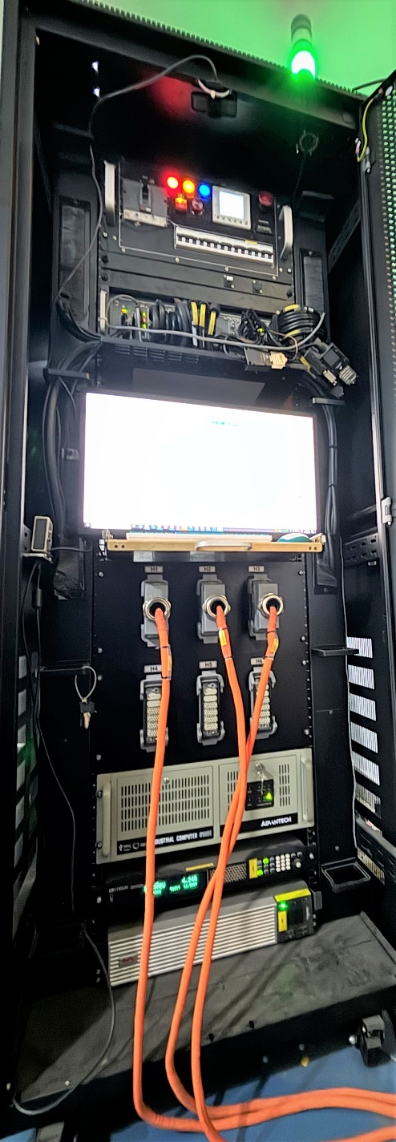
PDU with emergency
NI PXIe chassis
Monitor
Keyboard and Mouse
Signal Harting Wire
Signal Harting Connector
Server IPC
LOW PPS
UPS
RACK
Tower Lamp
Figure 1: Lifetime Tester.

Lifetime Tester Power supply Rack
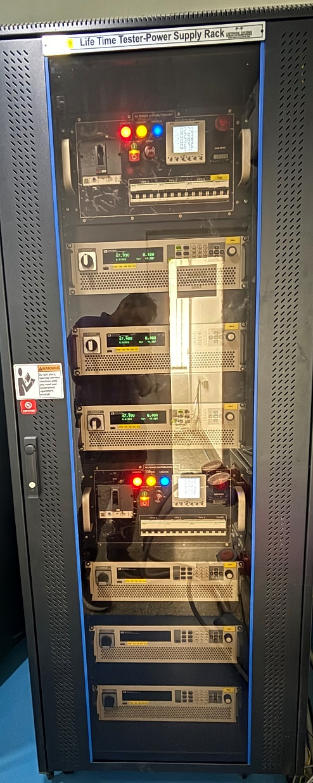
HV PPS
PDU with emergency
HV PPS
PDU with emergency
Figure 2: Lifetime Tester Power supply Rack.

Pictorial View of 3 Head Lifetime Tester.

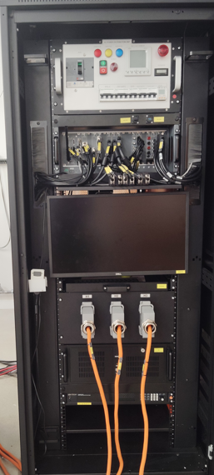
3 Head LTT Instrument Rack.
NI PXIe chassis
Monitor
Keyboard and Mouse
Signal Harting Connector
LOW PPS
PDU with emergency

Figure 3: 3 Head Lifetime Tester.

3 Head LTT Power supply Rack and RL Load.
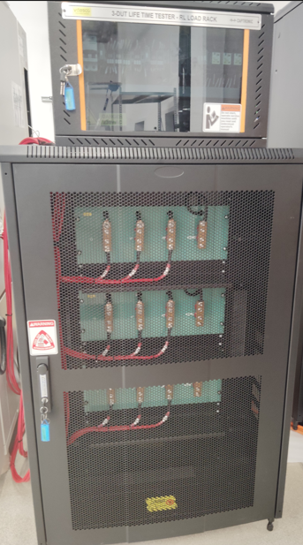

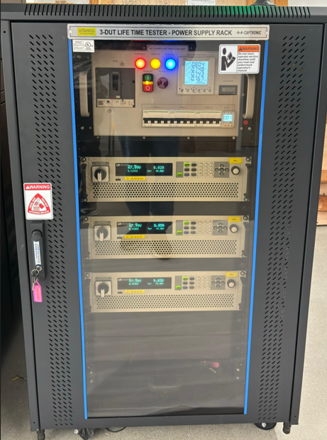

Figure 4: 3 Head Lifetime Tester Power supply Rack and RL Load.

Procedure to Power ON Console

Prior Inspection

- Prior to applying power to the system. Users should make several final inspections of the hardware components and interconnections.
- Visually inspect the system to ensure that all hardware components are present. Verify correct model numbers for each component.
- Inspect all components and NI modules to ensure that they are installed in the correct slot locations and placed securely in position and Refer the Figure 5.

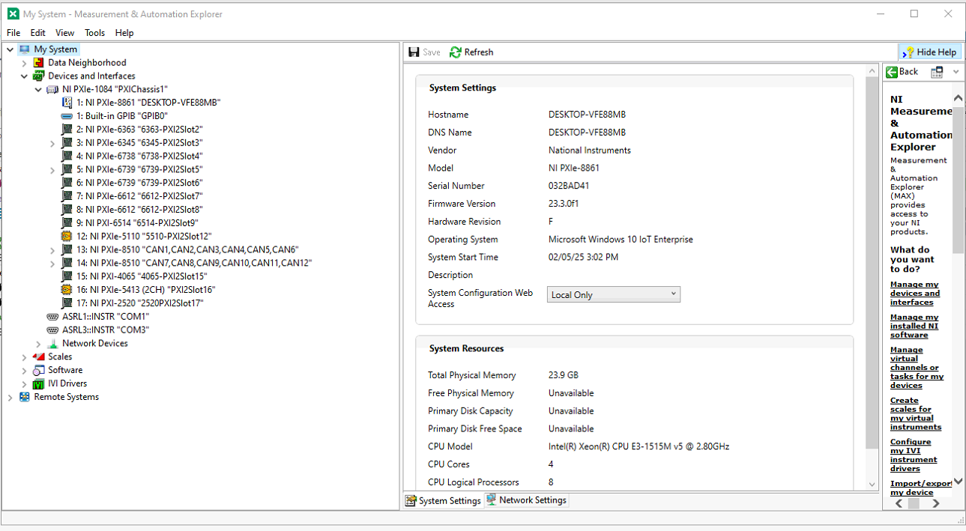
Figure 5: NI MAX Card Information
List the NI Hardware Slot details:
- Slot 1- PXIe-8861- Desktop PC.
- Slot 2- PXIe-6363- Analog Input.
- Slot 3- PXIe-6345- Analog Input.
- Slot 4- PXIe-6738- Analog Output.
- Slot 5- PXIe-6739- Analog Output.
- Slot 6- PXIe-6739- Analog Output.
- Slot 7- PXIe-6612- PWM Input and Output.
- Slot 8- PXIe-6612- PWM Input and Output.
- Slot 9- PXI-6514- Digital Input and Output.
- Slot 12- PXIe-5110- Oscilloscope.
- Slot 13-PXIe-8510- CAN.
- Slot 14-PXIe-8510- CAN.
- Slot 15-PXIe-4065- Digital Multimeter.
- Slot 16-PXIe-5413- Waveform Generator.
- Slot 17-PXI-2520- Relay Output

- Check that the incoming power is correctly wired to the power supply and that the system power is properly routed and connected to each instrument.
- Check that the output wiring connections are in place and properly terminated at the DUT end.
- Connect 415 (390-440) VAC supply to main inlet (MCCB) and turn ON main disconnection switch.

Turn ON the Main Switch

Turn ON the Main Toggle Switch
- Turn ON the Main Switch in the Instrument Rack PDU panel by toggle switch to up position. Refer the main switch control fig.6.
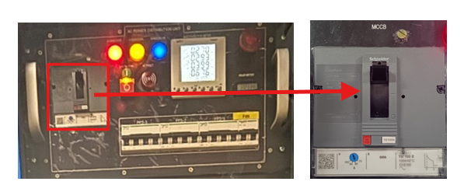
Figure 6: Main Power Switch

Verifying the ON the Three Phase Indicator
- Check the status of the RYB indication present in the AC PDU box. Refer Fig. 7.

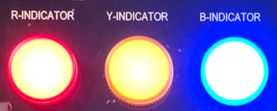
Figure 7: RYB Power ON Indicator

Turn ON the Rig Push Button Switch
- If the Mains on indicator does not turn on check the input power supply connection

Press the RIG ON push button
- Press the rig ON push button on the AC PDU box to turn ON the console. Refer the push button control fig.8.

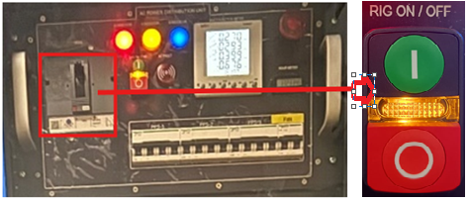
Figure 8: Rig ON/OFF Push Buttons

Ensure the Turn ON the MCB.

- Ensure the PPS 1, PPS2, PPS3, PXI, Rack, Circuit MCBs and ELR are ON. Refer fig 9

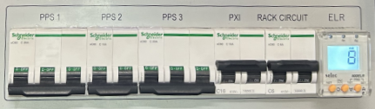

Figure 9: MCB ON Condition
- Turn ON the main MCB and individual MCB’s which is controlling the instrument.
- Check instruments are getting powered ON.

Ensure the Turn ON the PXI.

- Ensure the PXI are ON. Refer fig 10.

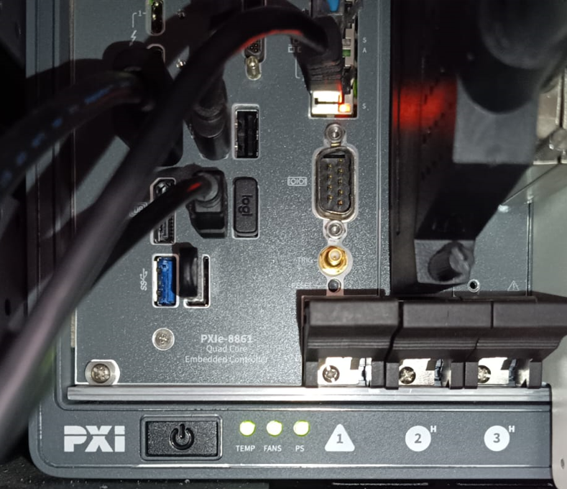
Figure 10: PXI ON Indication
- Turn ON the PXI power and wait for a few seconds.
- Ensure that the computer and monitor are ON. Ensure that the display cables are connected.
- Login to PC using the default password “VTLTT”.
Add here

Turn ON the UPS Switch

- Turn ON the UPS Switch in the Instrument Rack PDU panel. Refer to the main switch control fig.11.
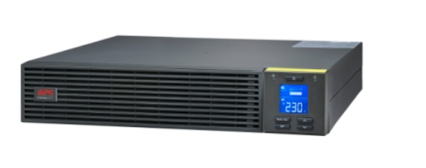
Figure 11: UPS On Indication

Turn ON the Low Voltage PPS Switch
- Turn ON the LV PPS Switch in the Instrument Rack PDU panel. Refer to the main switch control fig.6.
- Press the Switch c once the power is on, and the LED display will light up Fig 12

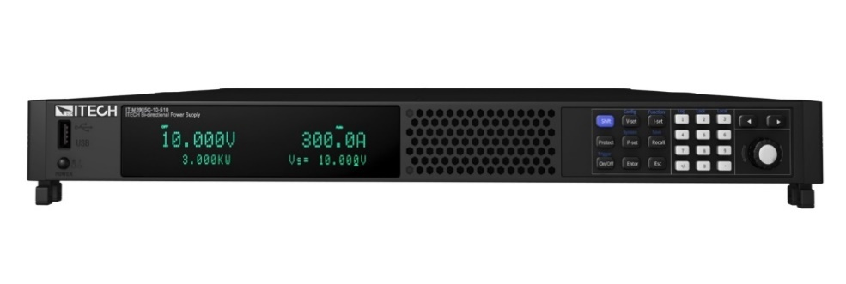

Figure 12: Low Voltage PPS On Indication

Turn ON the Power Supply Rack
- Turn ON the PDU Switch and MCB in the Power Supply Rack PDU panel. Refer to the main switch control Turn ON the Main Switch. 10.2
- Turn ON the High Voltage Programmable Power supplies.

Turn ON the High Voltage PPS Switch
- Turn ON the High Voltage Programmable Power supplies.
- Turn the knob clockwise once the power is on, and the LED display will light up Fig 13.

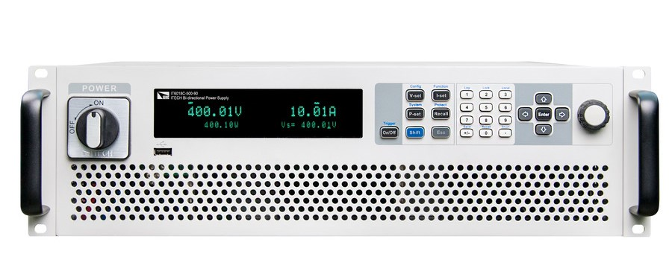
Figure 13: High Voltage PPS On Indication

Software Details

How to Launch LTT Application
- Run the LTT.exe application as an administrator. It’s located as a shortcut on the PC desktop.
- Application also located here - “D:\eDCU LTT\VT LTT Project\Exe\LTT.exe"
- Splash screen figure 14 appears in the desktop for few seconds.
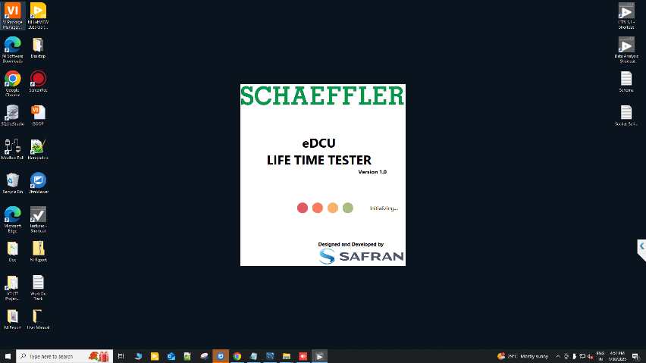
Figure 14: Lifetime Tester Splash Screen

User Interface Flow
The Main Screen of Lifetime Tester provides the user to enter different software features of the system such as Admin Login, User Account Manager, Setup, Auto Test and Diagnostic Test. The software user interface flow is given as schematic.

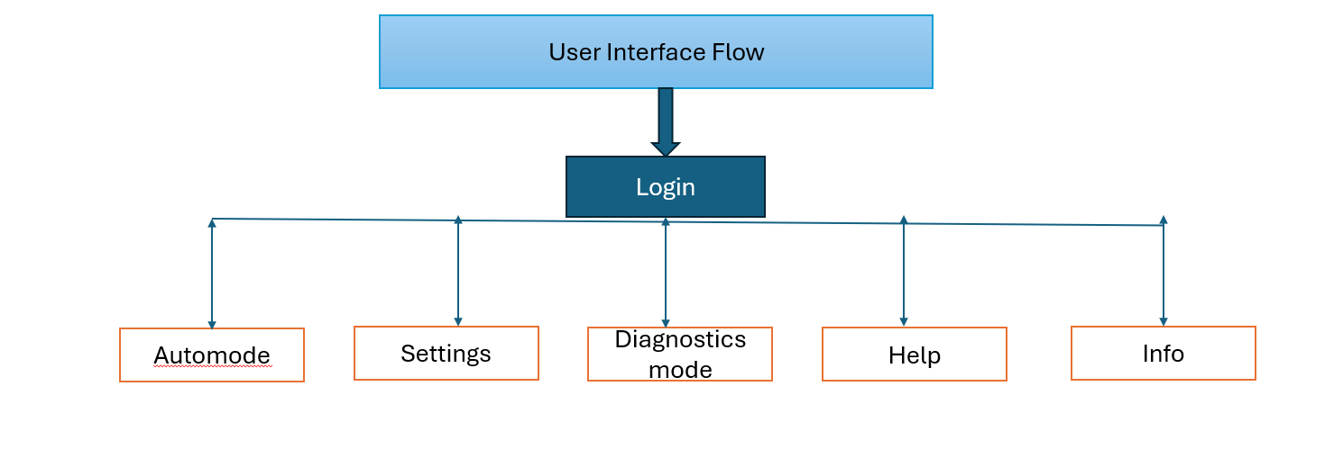
Figure 15: User Interface Flow

Main Screen
The Main Screen for ATE Tester has the following buttons as shown below. Only Login and Exit options are enabled till logged in.

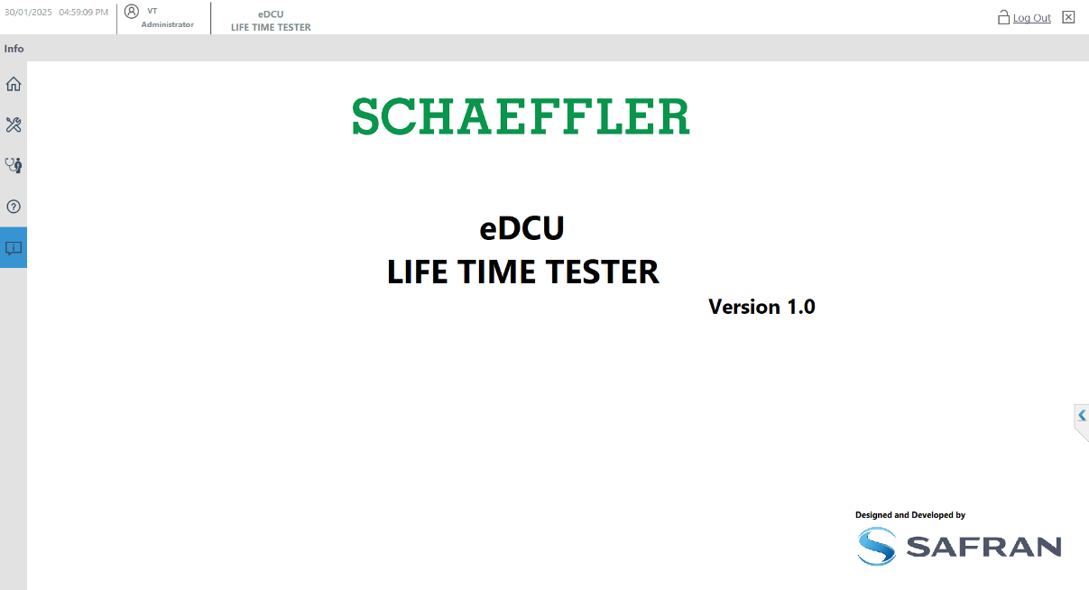

Figure 16: Main Screen

How to Login and Manage Users

Login Procedure
Once you launch the application the automatically login screen will appear. Incase didn’t appear you can login by clicking the “Login” button in main screen (Fig: 17), below shown User Login window will appear.
- Enter the Username - “VT” (default)
- Enter the Password – “VT” (default)
- Click the Sign In button.
- Finally click the Exit Button.
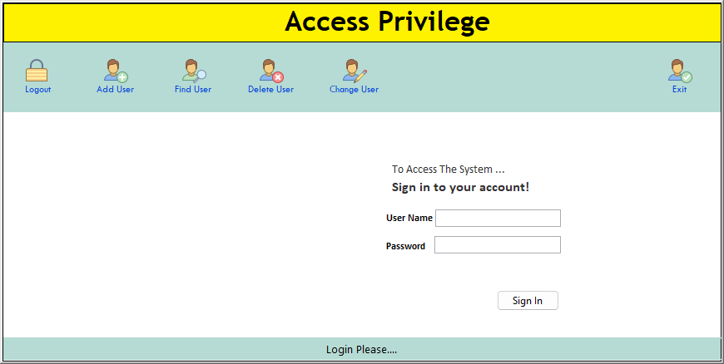
1
2
3
4
Figure 17: Login Panel

Creating a New User
By clicking the “Add user” Button from the main screen (Fig: 18), below shown Add user Screen (Fig: 18) will appear. It will be accessed only by admin to add, delete or edit the user accounts.
- Click the Add User Button.
- Enter the Username
- Enter the Password.
- Confirm the Password Again.
- Select the appropriate profile (Operator, Specialist, Administrator) based on the required access level.
- Click the “OK” button.
- Finally click the Exit Button.
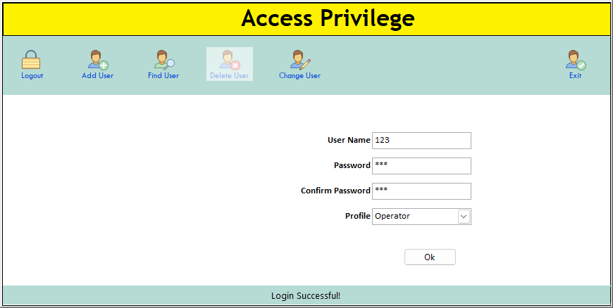
1
3&4
5
6
2
7
Figure 18: Add User Screen

- If your profile is set to "Operator," you can access the following modes: Home, Help, and Info.
- If your profile is set to "Administrator," you can access the following modes: Home, Help, Info, and Settings.
- If your profile is set to "Specialist," you can access the following modes: Home, Help, Info, Settings, and Diagnostics.

Change User / Admin Password
The admin password can be changed by using the existing password. To change the password, select the user and click “Change Password” Button in User Account Manager Window (Fig:10), below shown Change Password Screen (Fig: 19) will appear.
- Click the Change User Button.
- Enter the Username.
- Enter the Current Password.
- Enter the New Password.
- Enter the Confirm the Password.
- Click the Change Button.
- Finally click the Exit Button.
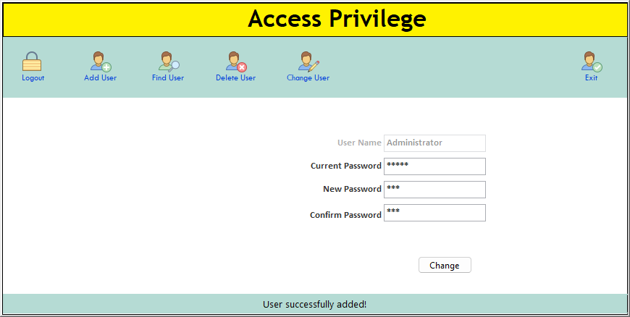
1
2
3
4&5
6
7
Figure 19: Change User / Admin password

Delete Username from List
The admin is a default user ID which cannot be deleted from the user list. To delete the user details, select the user and click “Delete User” button below shown Account Manager Screen (Fig: 20). The Confirmation screen will appear, Click Ok to confirm for delete the selected user details.
- Click the Delete User Button.
- Select the User details.
- Click the Delete User Button.
- Finally Click the Exit.

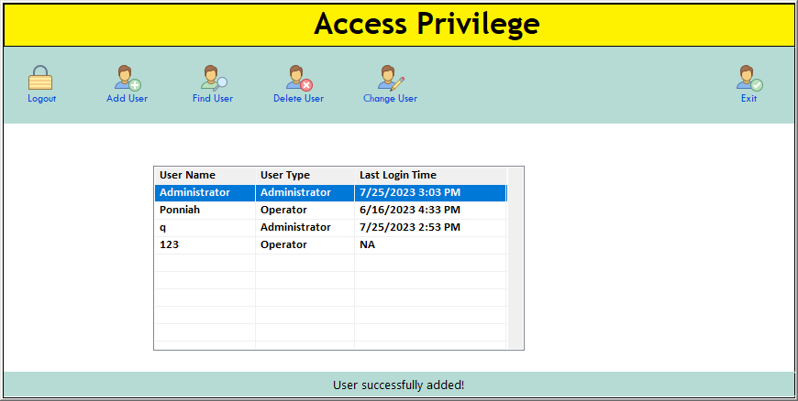
1&3
2
4
Figure 20: Delete username from the list.

Find Username from List
The Find the from the user list. To Find the user details for Username, User Type and Last Login time. The Confirmation screen will appear Fig 21, Click Ok to confirm for delete the selected user details.
- Click the Find User Button.
- Select the User details.
- Finally Click the Exit.

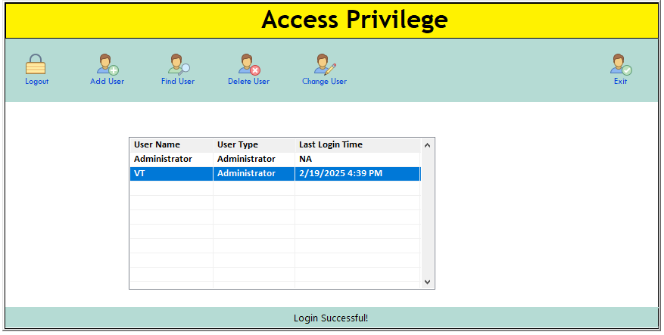
1
2
3

Figure 21: Find username from the list.

Procedure to Change System Configuration
Clicking the 'Settings' button from the main window (Fig. 16) will open the window shown below (Fig. 22). Select the schema and table names in the respective fields, then choose 'Import' or 'Export' to apply the changes. This module imports and exports data based on the selected schema and table files.
- Click the Setting Screen.
- Click the Database Configuration Tab Button.
- Select the List the Schema Name.
- Select the List of the Table Name.
- Click Export and Import the File(.CSV).
- Click the Refresh button and show the data in Window.

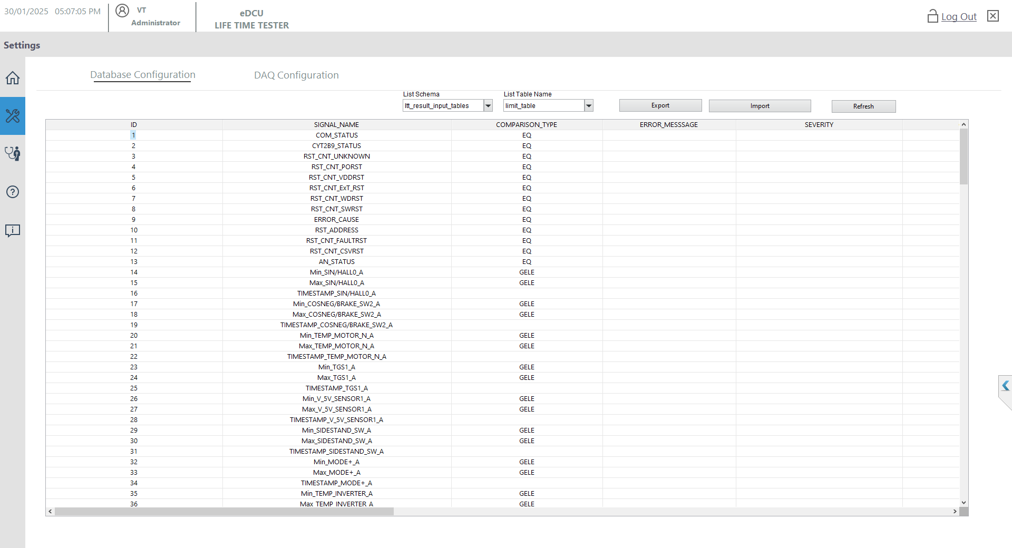
1
2
3
4
5
6
Figure 22: Settings Screen

Procedure for Import data to change existing configuration
- Click the Settings Screen button Refer the Fig 22.
- Click the Database configuration Tab Button.
- Select the List of the schema.
- Select the List of the Table Names.
- Click the Import Button.
- Choose the respective path and select the file(.CSV).
- Selected file shows the file name.
- Click the OK button
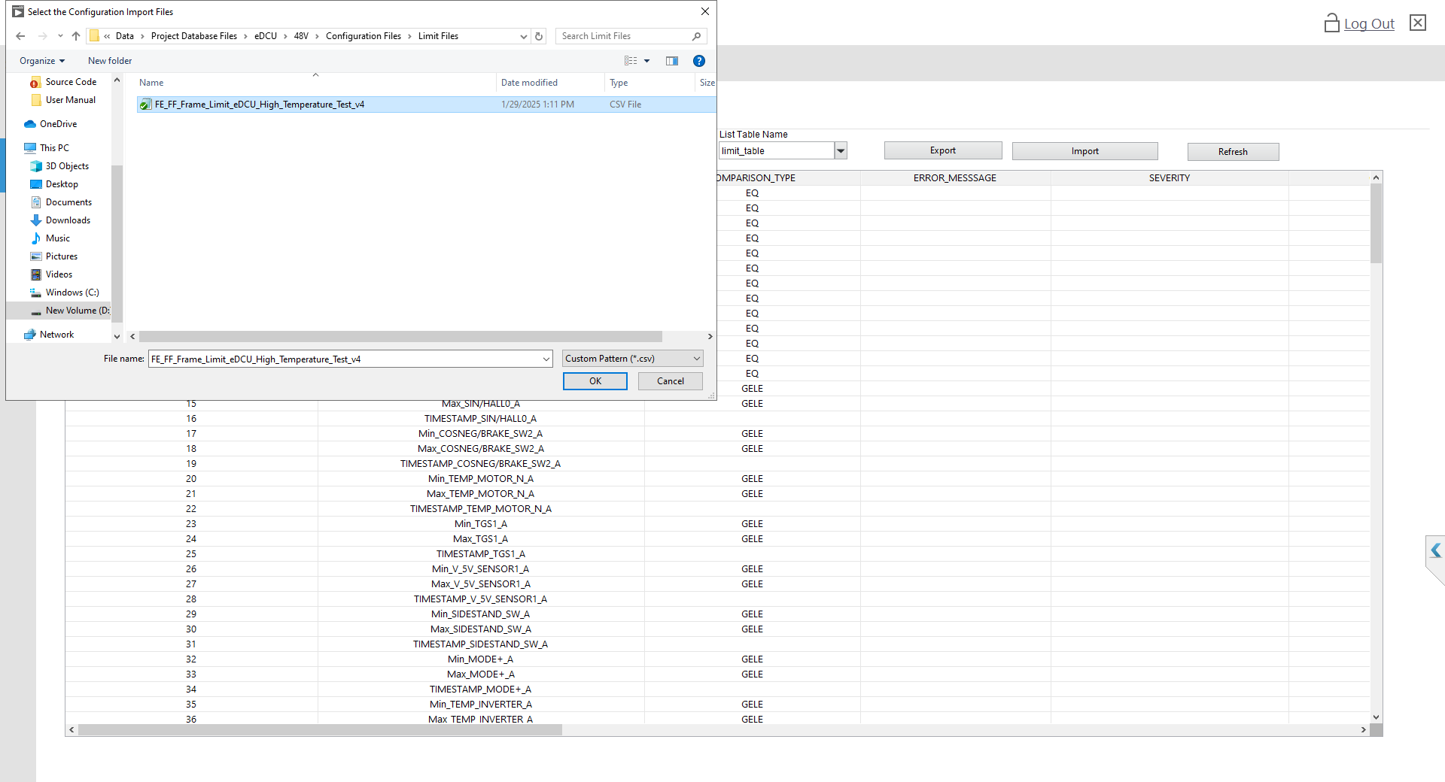
1
2
3
4
5
6
Figure 23: Setting Import Data

Procedure Export data in .csv file
- Click the Settings Screen button Refer the Fig 22.
- Click the Database configuration Tab Button.
- Select the List of Schema List.
- Select the List of Table List.
- Click the Export button.
- Select the Folder and Enter file name.
- Show the File name(.CSV).
- Click the OK button.
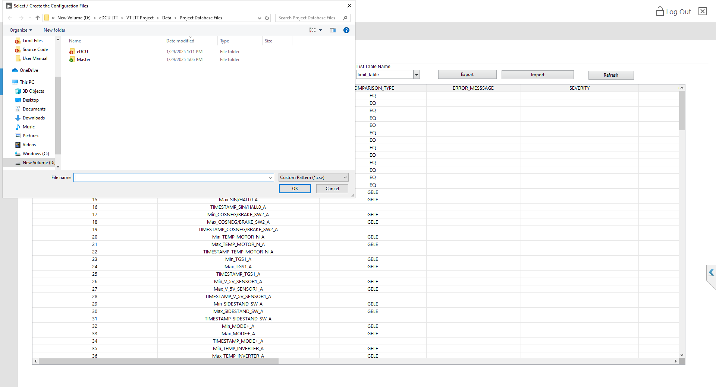
1
2
3
4
5
6
Figure 24: Settings Export Data

Procedure the Setting Screen Update.
- Click the Settings Screen button Refer the Fig 22.
- Click the Database configuration Tab Button.
- Select the List of Schema Names.
- Select the List of Table Names.
- Click the Refresh button.
- Show the Data for Selected the Schema and Tables Name

1
2
3
4
5
6
Figure 25: Settings Screen Update View

Detail about DAQ Configuration tab is missing

Procedure the Setting DAQ Configuration Screen Update.
- Click the Settings Screen button Refer the Fig 22.
- Click the DAQ configuration Tab Button.
- Select the List of DUT ID.
- Select the List of Channel Type.
- Rename the Signal Name as per the required specifications.
- Provide options to Enable or Disable signals.
- Click the Refresh button to update the status.
- Ensure that the Renamed Signal Name, along with the Enable and Disable options, are properly updated.
- Display the data for the selected DUT ID and Channel Types for reference.
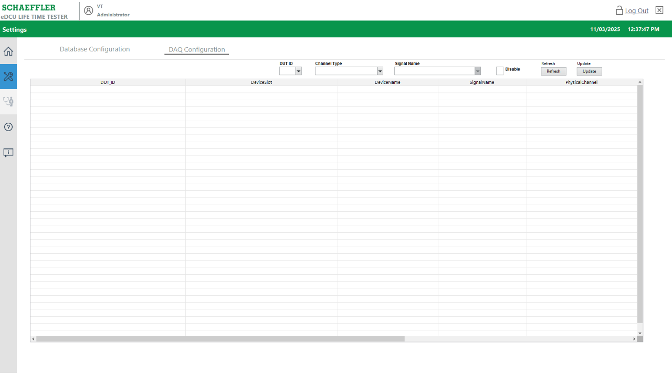
1
2
3
4
5
6
7
8
9
Figure 26: DAQ Configuration Settings Screen Update View

Procedure the Select the DUT ID and Channel Type Screen Update.
- Click the Settings Screen button Refer the Fig 22.
- Next, click the DAQ Configuration tab button to access the configuration settings.
- From the available options, select the list of DUT IDs.
- Then, choose the list of Channel Types that you wish to configure.
- Finally, display the data for the selected DUT ID and Channel Types to review the current settings.
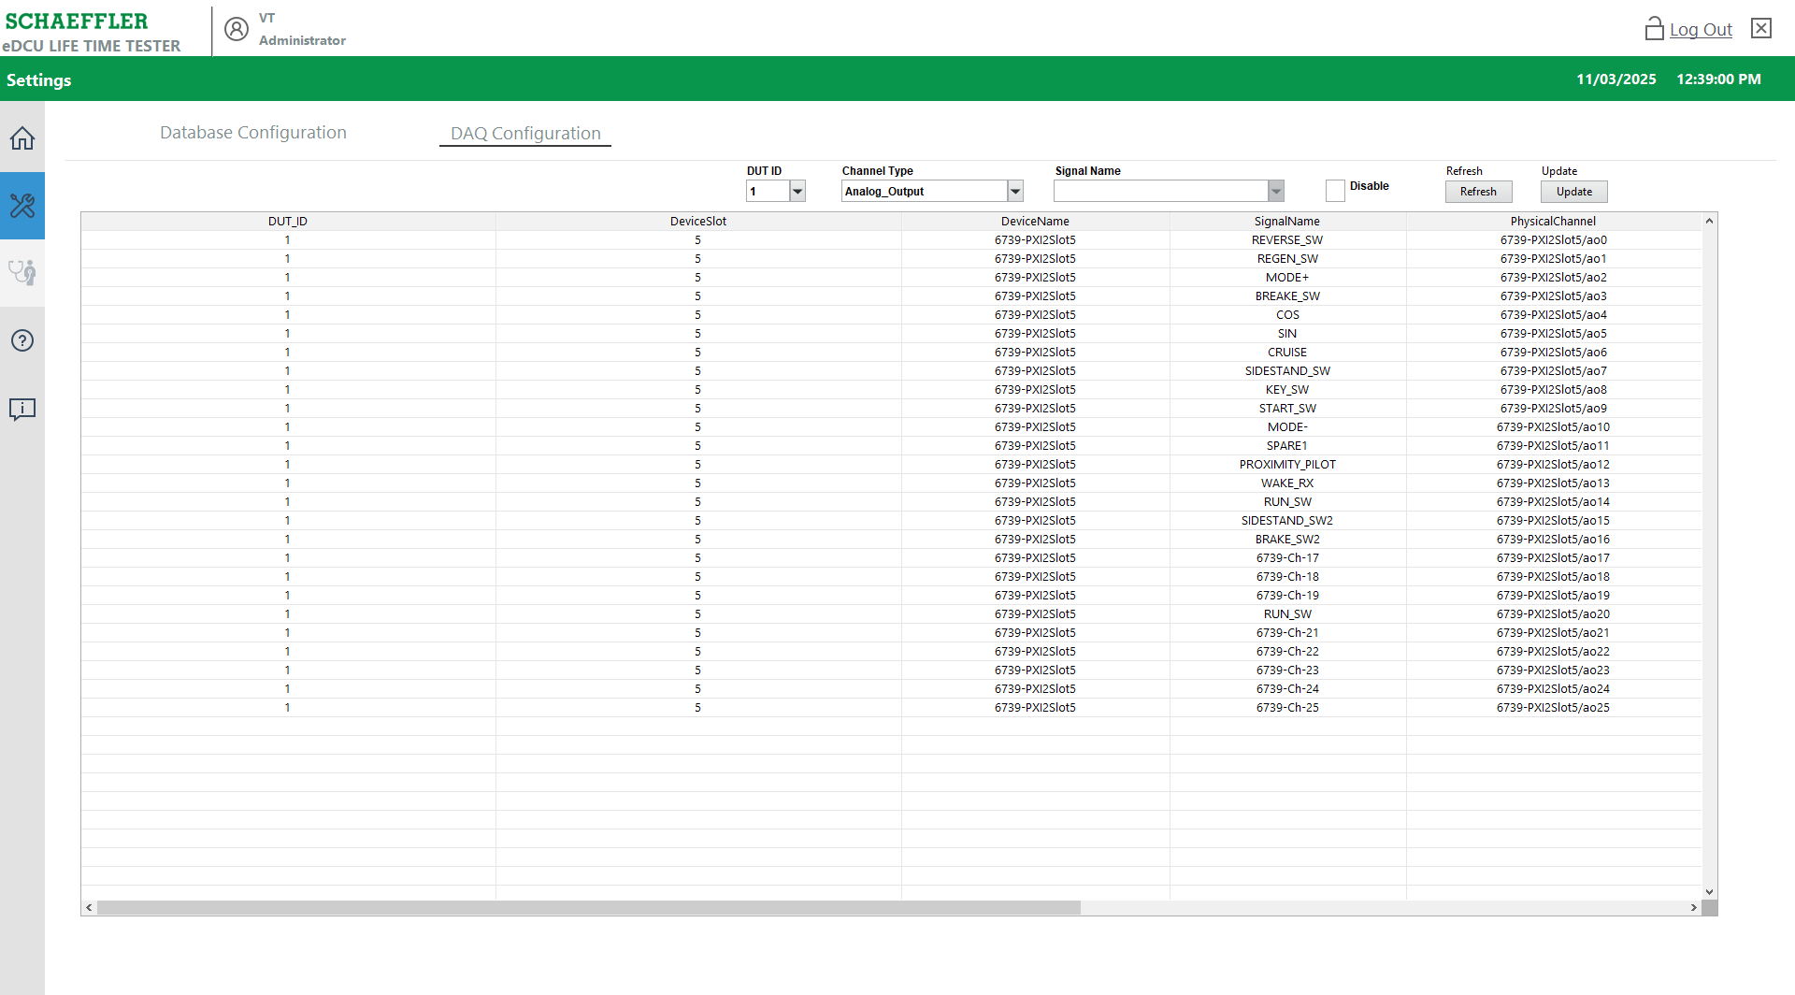
1
2
3
4
5
Figure 27: Select DUT ID and Channel Type Update View

Procedure the Double Click the Select the Specfic Row Signals.
- Click the Settings Screen button Refer the Fig 22.
- Next, click the DAQ Configuration tab button to access the configuration settings.
- Select and double-click the Signal Row to view its details.
- Display the Signal Name for the selected signal.
- Show the Enable or Disable status for the signal.
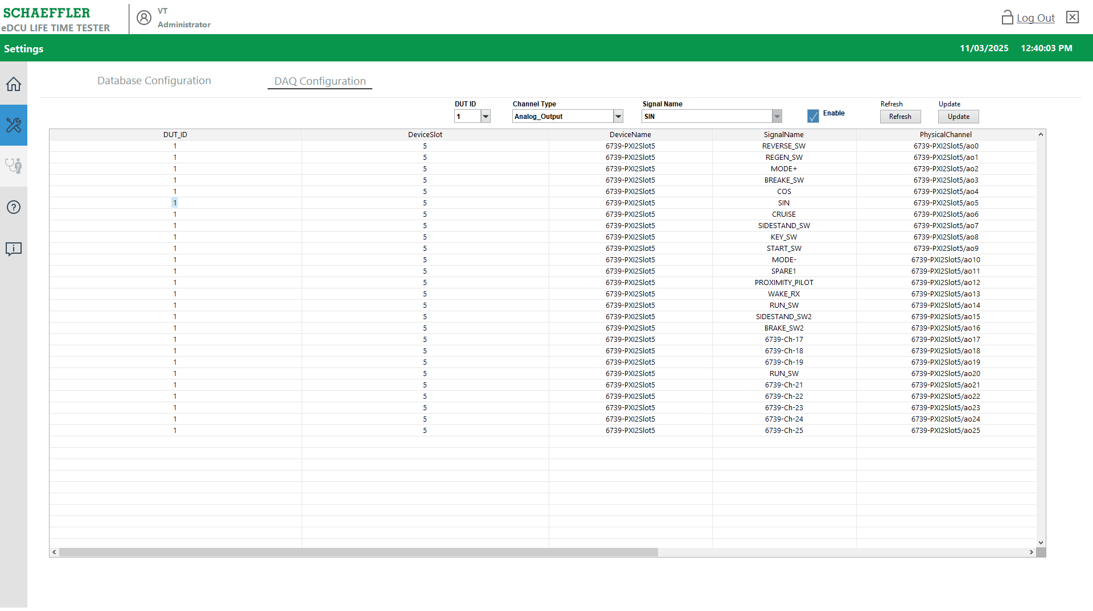
1
2
3
4
5
Figure 28: Select the Row Signals Update View

Procedure the Update Signal Name and Enable and Disable Option.
- Click the Settings Screen button Refer the Fig 22.
- Click the DAQ Configuration tab button to access the configuration settings.
- Rename the Signal Names as needed.
- Provide the option to Enable or Disable the signal using the respective buttons.
- After making the changes, click the Update button to save the modifications.
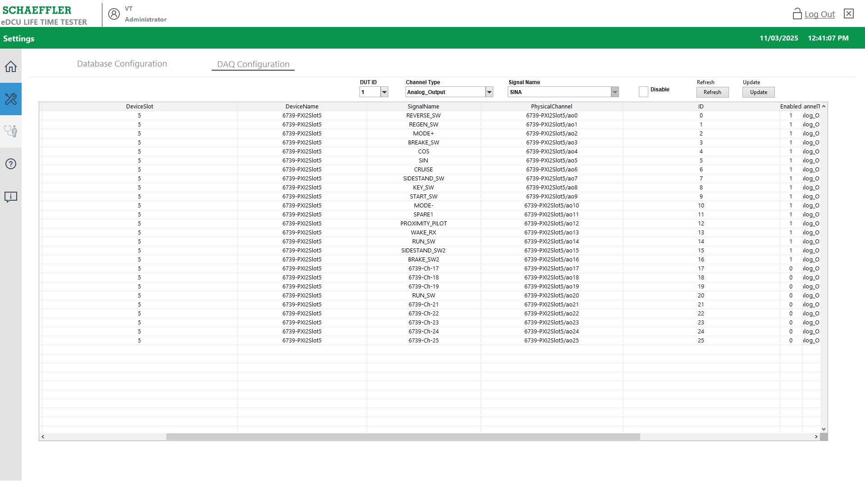
1
2
3
4
5
Figure 29: Settings Screen Update View

Procedure the Setting Screen - Refresh the DAQ Configuration.
- Click the Settings Screen button Refer the Fig 22.
- Click the Database Configuration tab button to access the configuration settings.
- Select the list of DUT IDs from the available options.
- Choose the List of Channel Types that you need to configure.
- Click the Refresh button to update the data.
- Display the data for the selected Schema and Table Names based on the DUT ID and Channel Type.
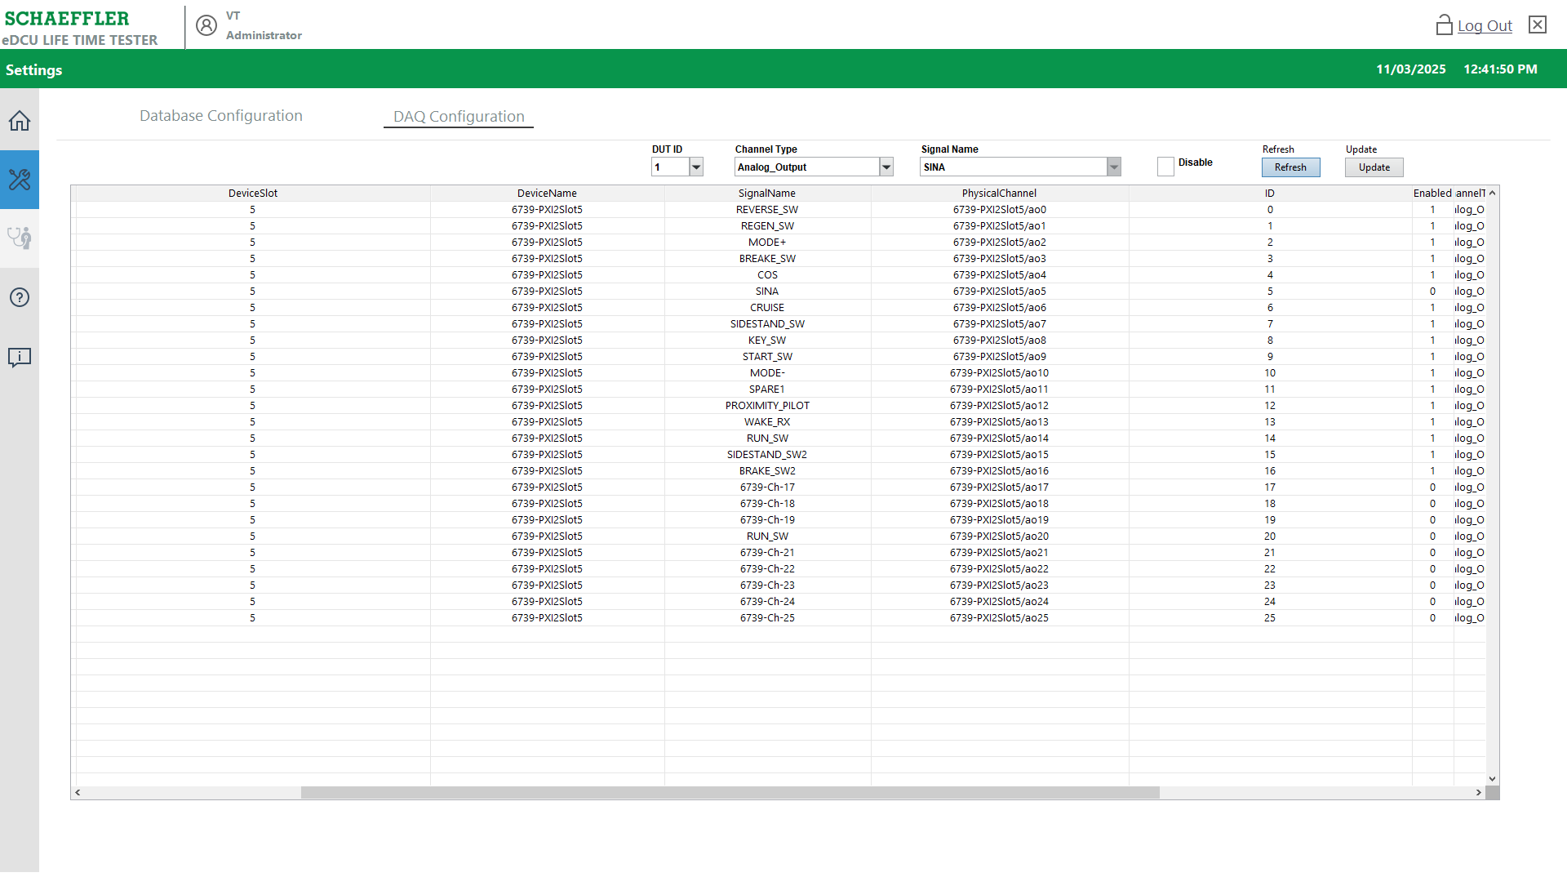
1
2
3
4
5
6
Figure 30: Refresh the DAQ Configuration

Procedure for Auto Mode (To Start New/Existing Test)
Auto mode is used to test the test case by selecting and applying various sequences to run Refer the Figure 31.
- Click the Home symbol button to enter Auto mode.
- After clicking the Home button, the Test Stand Login pop-up will appear.
- Click the 'OK' button (with the password field empty).

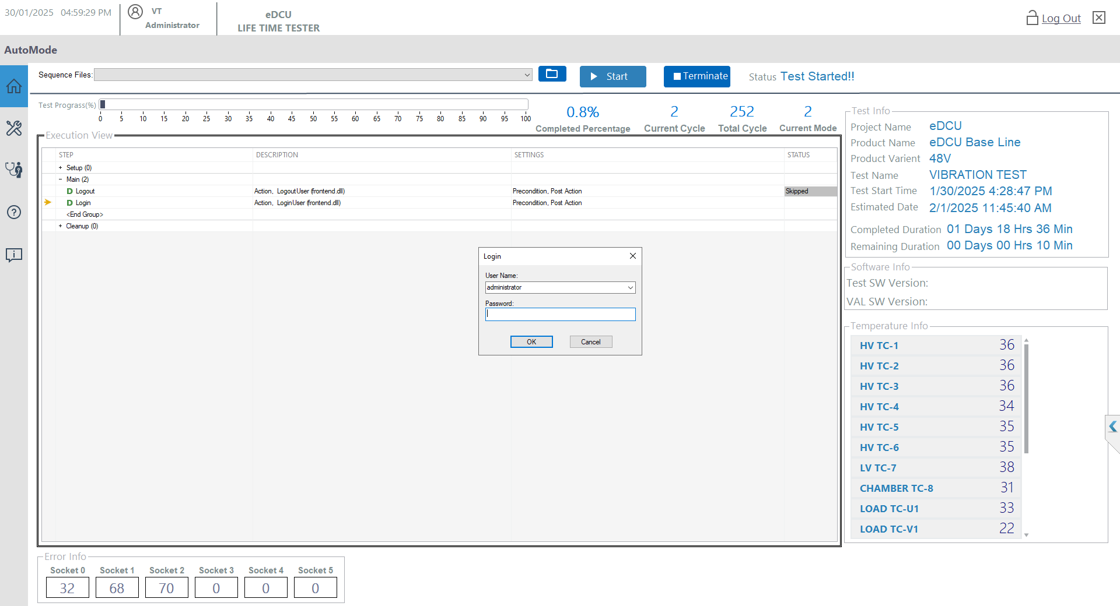
1
2
3
Figure 31: Auto Mode and Login Test Screen

Auto Mode Details Screen
- Click the Open Sequence button for Purpose and Select the Sequence file Location is D/eDCU LTT/VT LTT Project/Client Sequence/eDCU/eDCU LifeTimeTest_VAL12.seq
- Show the Selected Sequence file was loaded.
- Click the Start button purpose for Test Start.
- Click the Terminate button for purpose stop the test.
- Status for Test running status update.
- Show for Test progress update and Complete percentage, Current cycles, Total Cycles and Current Mode.
- Show for Test Information in Project Name, Product Name, Product Info, Test Name, Test Start Time, Test Estimated Time, Test Completed Time and Remaining Duration.
- Show for Software Information in Test SW Version and VAL SW Version.
- Show for Temperature Information in Power Supply Temperature, Chamber Temperature and Load bench temperature.
- Show for Execution View Windows for Sequence current step running execution View.
- Show for the Error Information for socket-based failure count.
- Click the Exit button to close the application entirely.
2
1
3
4
5
7
6
8
9
11
12
10
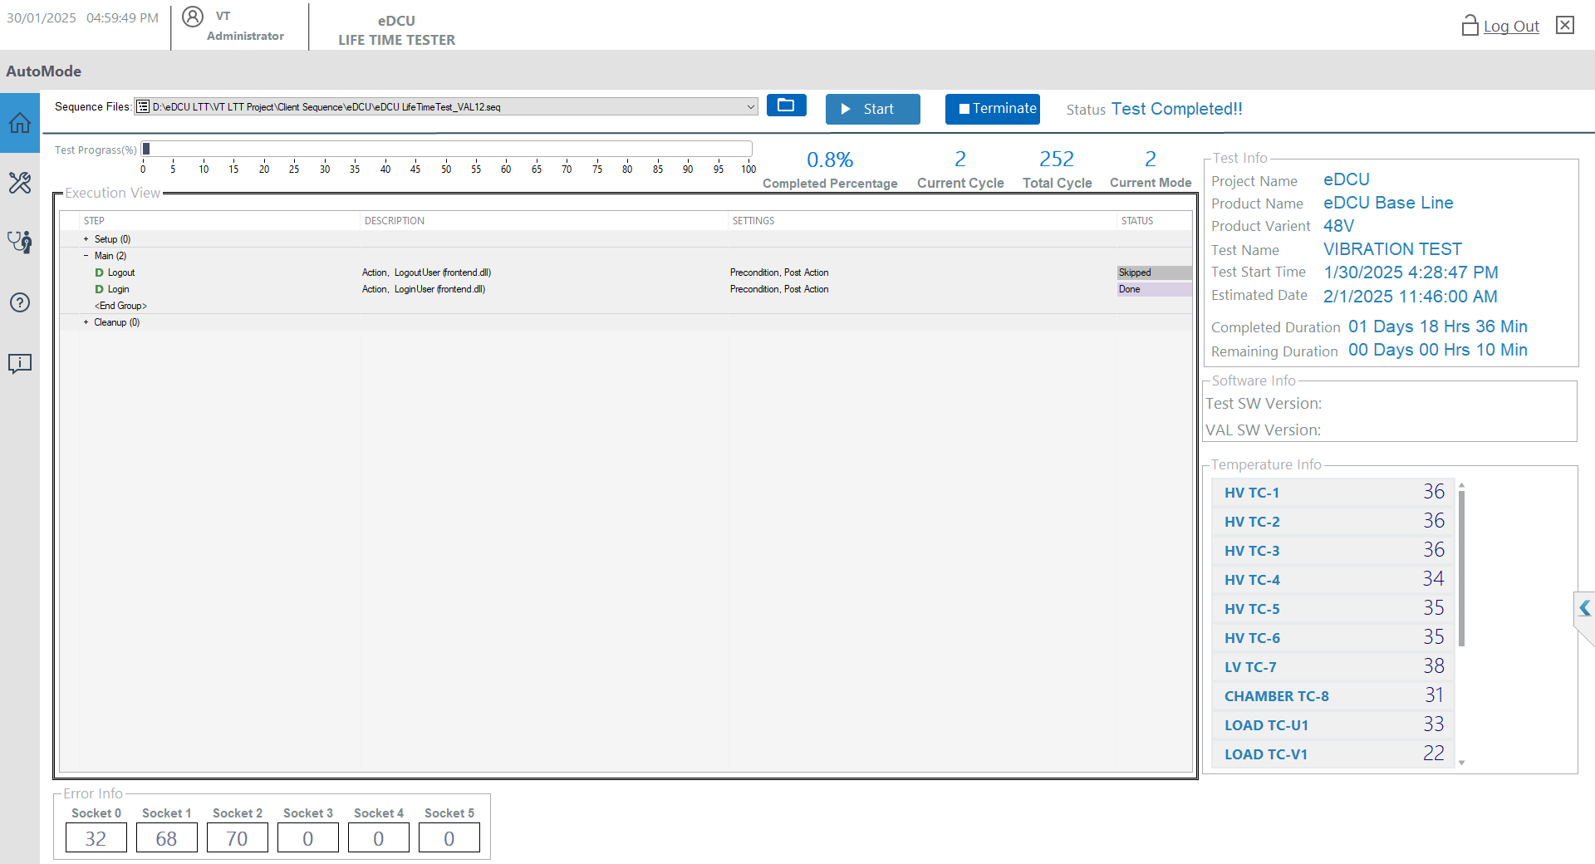
Figure 32: Auto Mode Screen User Interface Information

Sequence File Loading and Start the Test.
- Click the Open Sequence button and Select the Sequence file Location is
D/eDCU LTT/VT LTT Project/Client Sequence/eDCU/eDCU LifeTimeTest_VAL12.seq
- Show the Selected Sequence file was loaded.
- Click the Start the Button
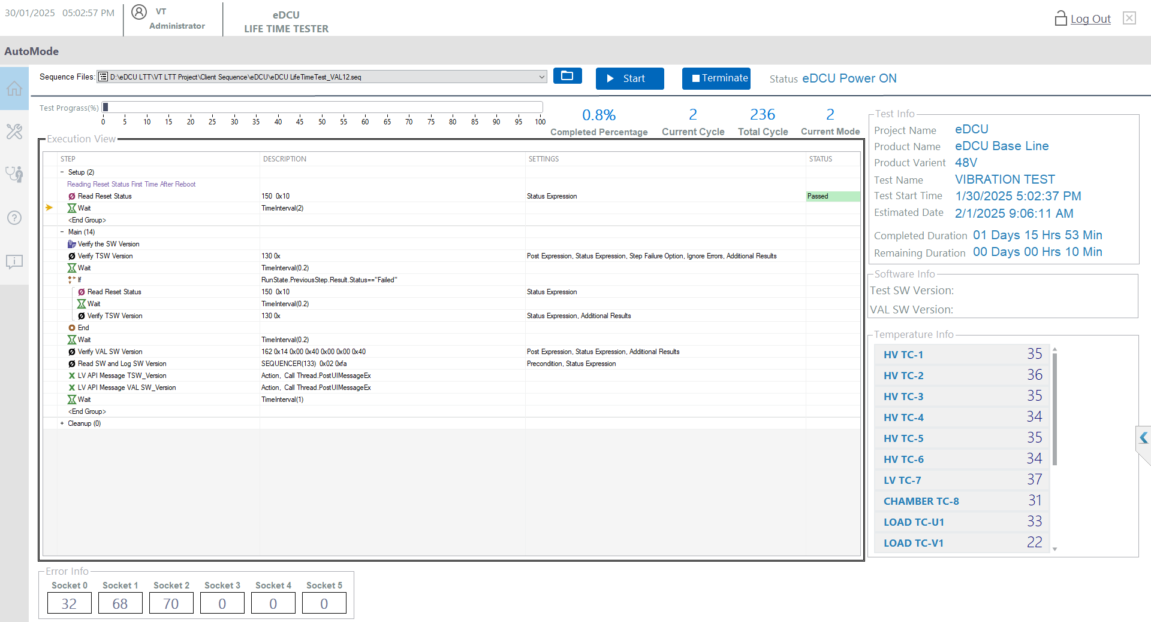
1
2
3
Figure 33: Sequence File Loading and Start Test

Number of Socket Entry
- Enter the number of sockets (eDCUs connected).
- Click the OK Button.
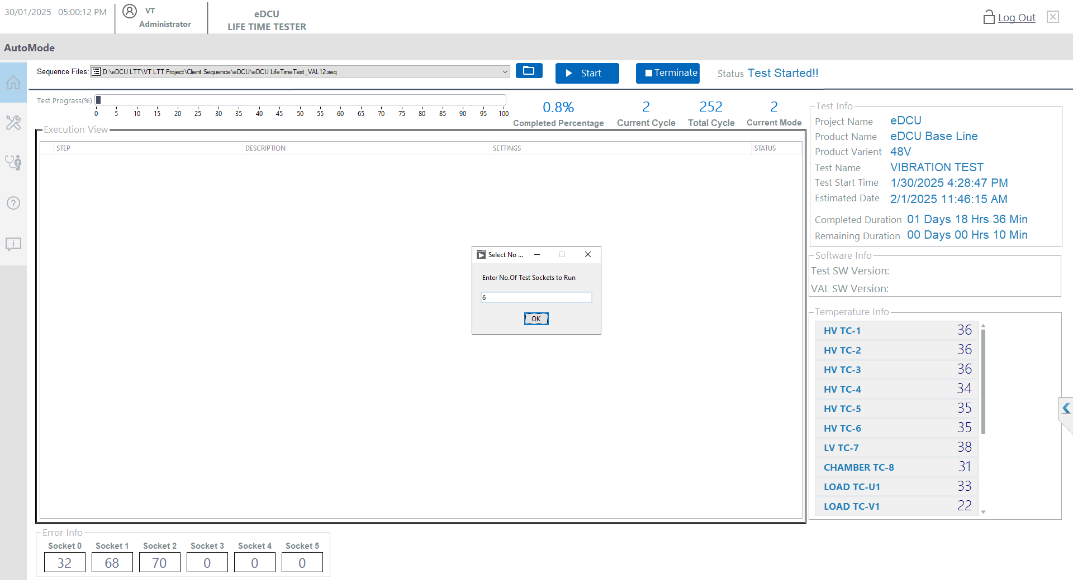
1
2

Figure 34: No of Socket Entry

Serial Number Entry Screen
- Enter the eDCU serial number for each socket.
- Tick 'Disable Test Socket' option in case you don’t want to run that socket.
- Click 'GO' to proceed with the test.
- Clicking 'STOP' will abort the test.
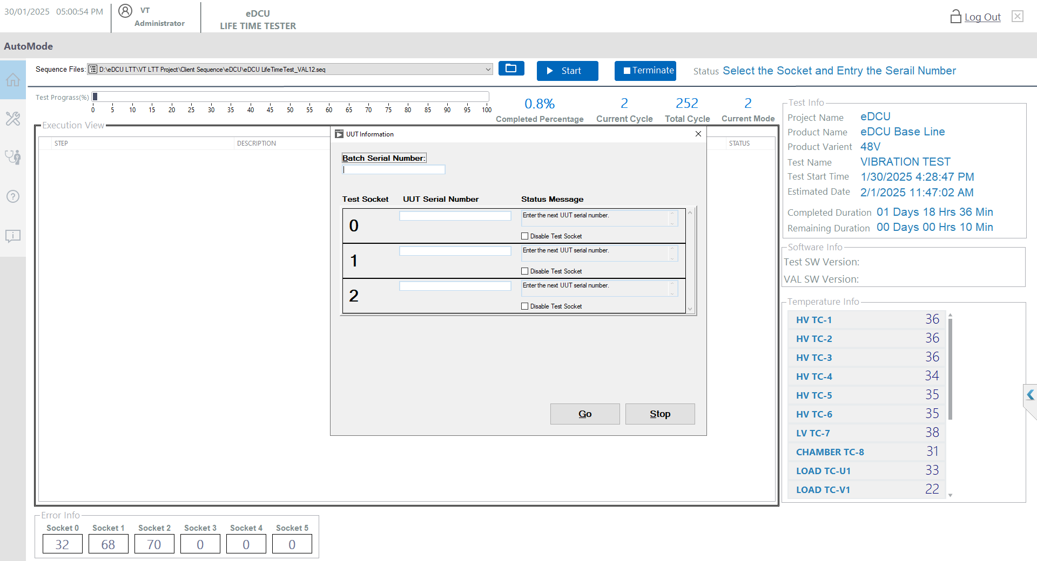
1
2
3
4
Figure 35: Serial number entry

Test Selection on Screen(New Test/ Resume test)
- The Test Selection window offers options to select a test, start a new test, continue the last test, or cancel.
- Clicking the ‘New Test' will initiate a fresh test.
- Clicking 'Continuous Last Test' will resume the previous test from the last cycle.
- Clicking 'Cancel' will abort the current test.
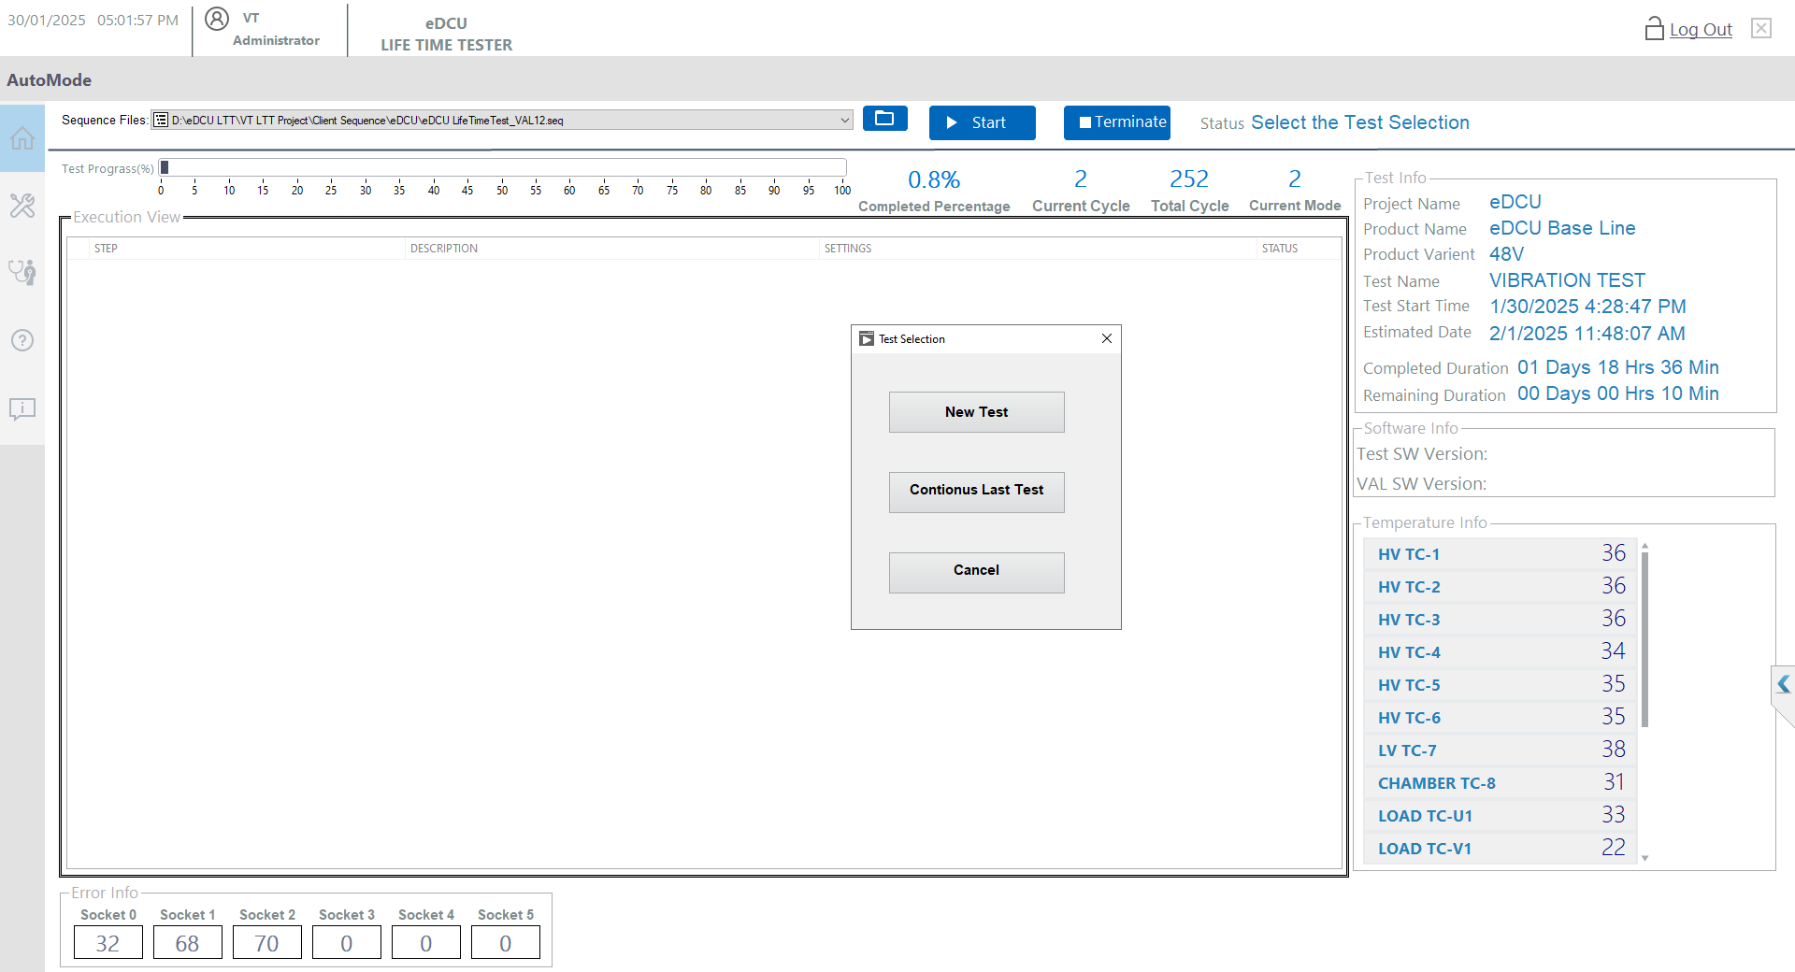
1
2
3
4
Figure 36: Test selection

New Test
Follow the procedure outlined in sections 11.6.1 to 11.6.5, refer to the images provided for guidance
- Enter the project name.
- Select/Enter the product name.
- Select/Enter the product variant.
- Select the test name.
- Select/Enter the test phase.
- Provide the test description.
- Enter the temperature chamber detail if applicable.
- Verify the total number of cycles.
- Click the "OK" button.
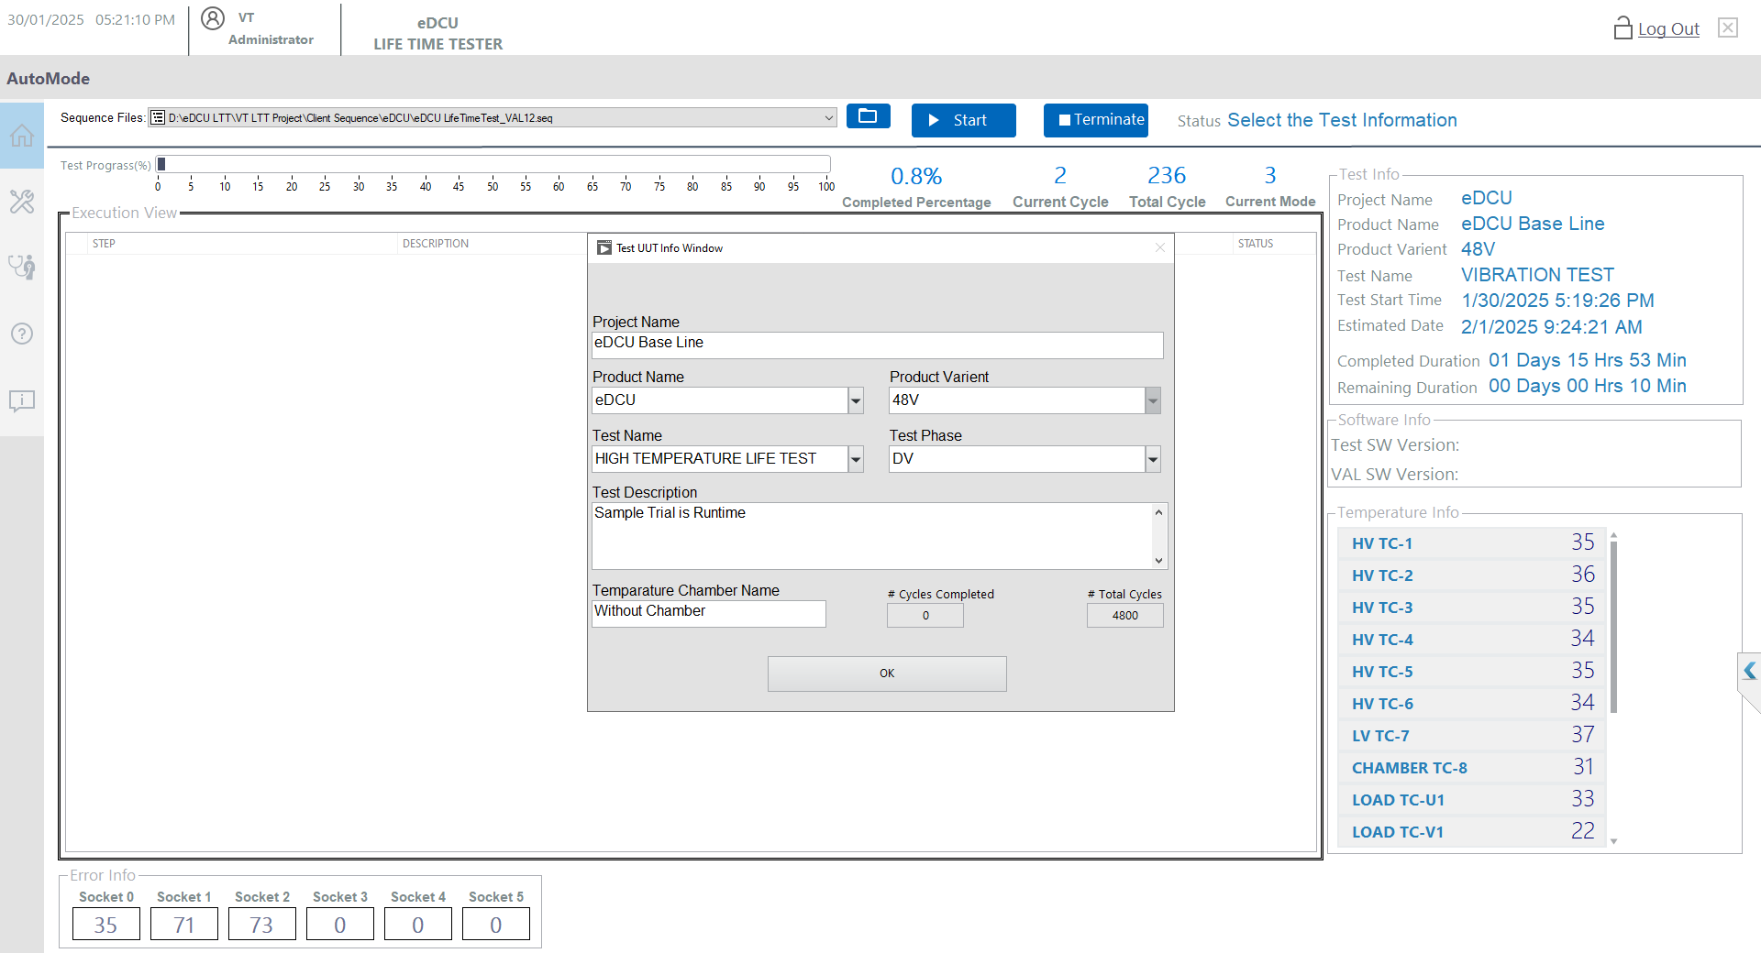
1
2
3
4
5
6
7
8
9
Figure 37: New Test UUT Test Info

Continuous/Resume Test
Follow the procedure outlined in sections 10.6.1 to 10.6.5, refer to the images provided for guidance
- The last schema is automatically updated with test UUT information. Select from dropdown incase you wish to start another test.
- Verify the Project Name.
- Verify the product name.
- Verify the product variant.
- verify the test name.
- Verify the test phase.
- Provide the test description.
- Enter the temperature chamber detail if applicable.
- Verify the current and total cycles.
- Click the "OK" button.

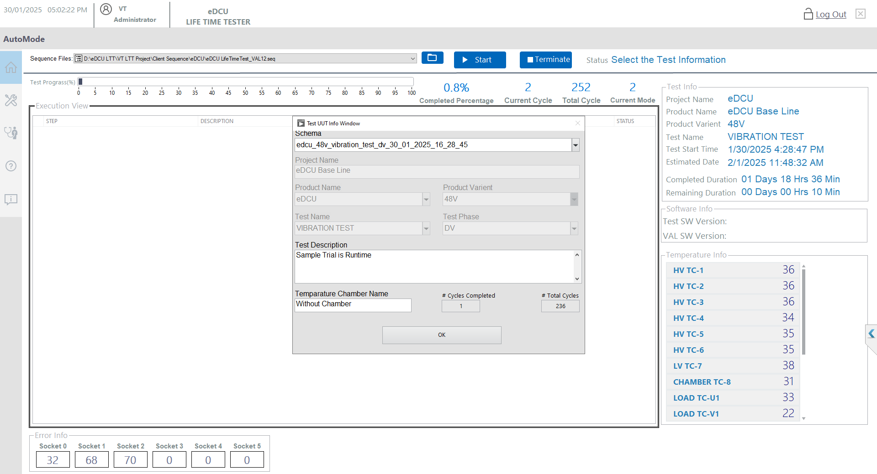
1
2
3
4
5
6
7
8
9
10
Figure 38: Continuous Test Selection

Verify Sequence Running
- The test execution window is updated to display the current step being processed.

View the Running Sequence
Figure 39: Sequence Running

Verify Wait Monitor step while a mode is running.
- Display the current state.
- Display the running test mode.
- Display the running cycle.
- Display the current and target temperatures.
- Display the wait time and remaining time.
- Display the eDCU RMS current values.
- Display the high voltage PPS current values.
- Display the status update.
- Display the raw power status.
- Display the monitor state for RMS current and chamber.
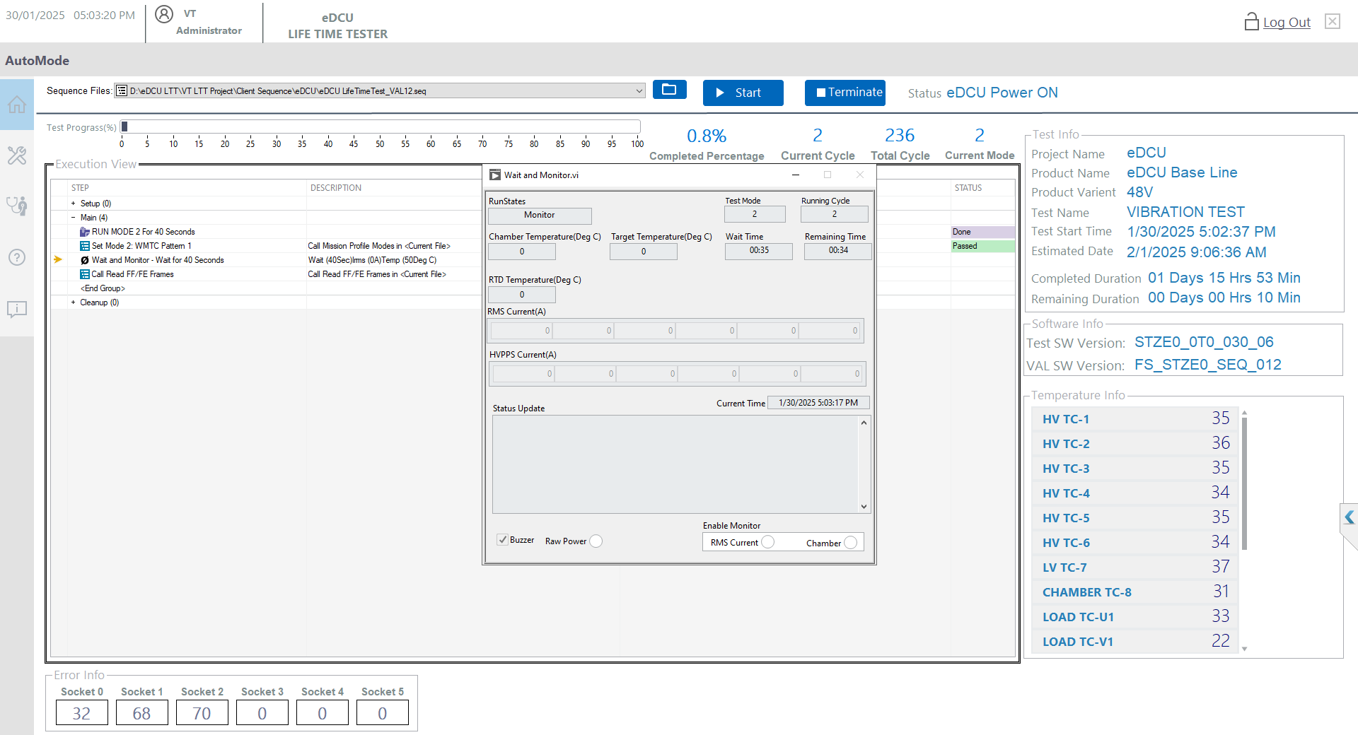
1
2
3
4
5
6
7
8
9
10
Figure 40: Wait Monitor

Procedure for Terminating a Test
- Click the "Terminate" Button: Press the "Terminate" button to end the test.
- Confirm Termination: If prompted, click "OK" or "Yes" to confirm the test termination.
- Verify Test Status: Ensure the test status reflects that it has been successfully terminated.
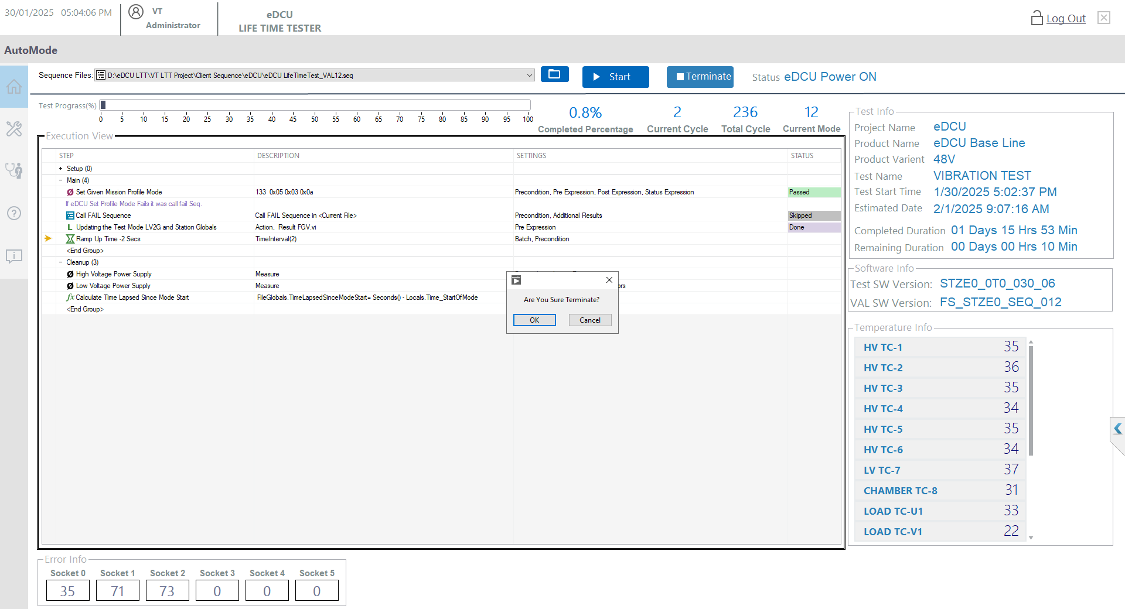
1
2
3
Figure 41: Test Terminate

Verify Test Termination Completion.
• Verify Test Status Ensure the test status reflects that it has been successfully terminated.
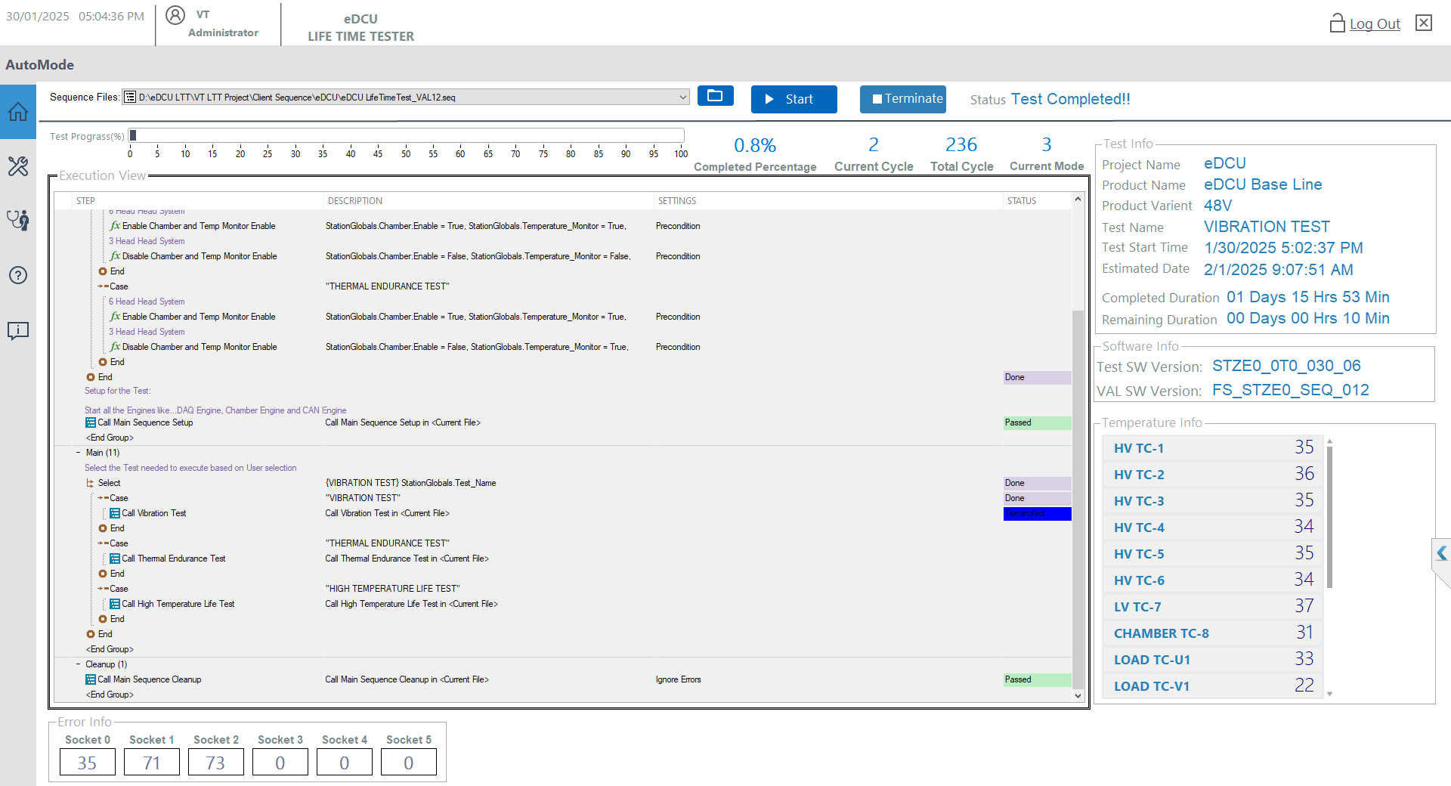
1
1
Figure 42: Test Terminate Completed

Procedure Stop the Test in case of any Error
- While the test is running, and a runtime error occurred then you will see an error screen as shown below
Note: Take a screenshot and save it for future reference
- Select the 'Run Cleanup' option
- Tick the “Do not show Dialog Box Again for this Batch”
- Click the 'OK' button.
.
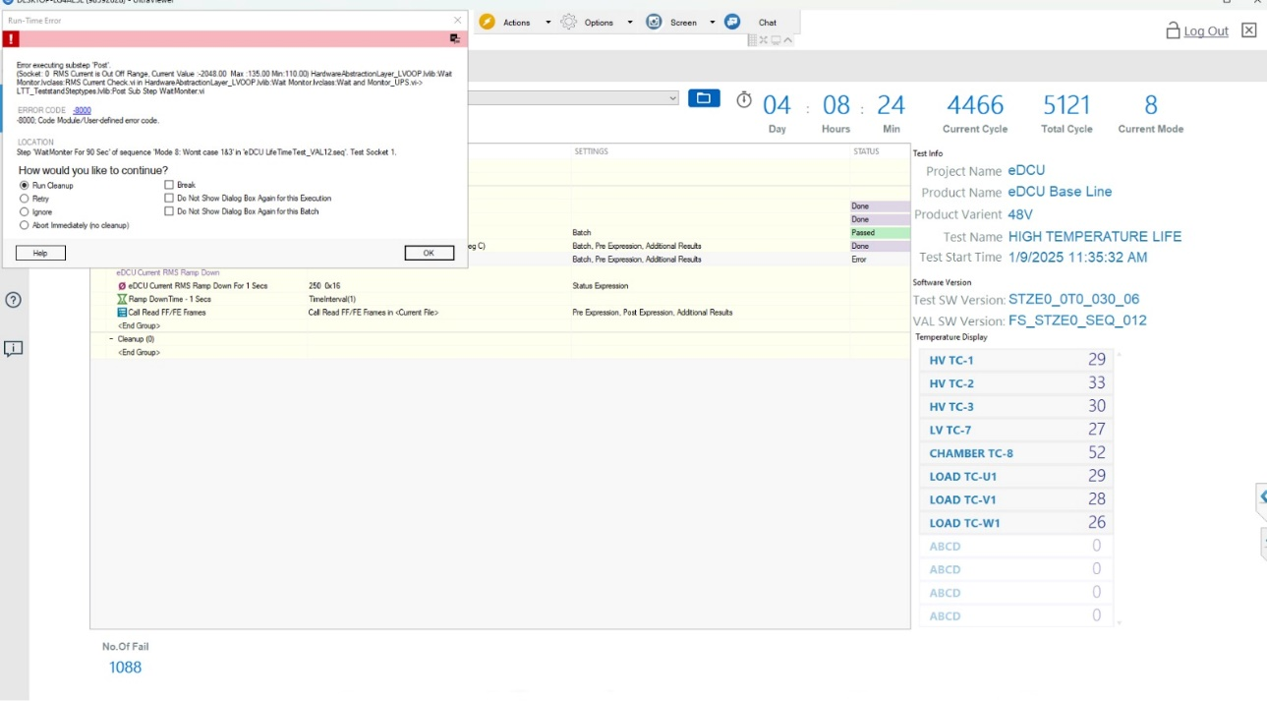
1
2
4
3
Figure 43: Error Handle

Procedure for Exiting the Application.
- Terminate the test incase test is running.
- Click the 'Exit' button.
- Click the OK to confirm the exit or Cancel button if it was by mistake
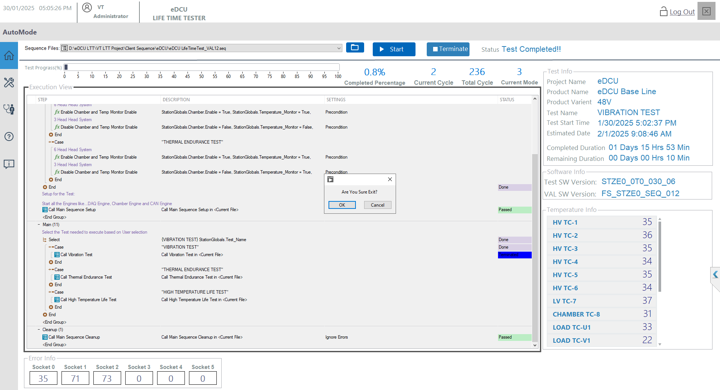
1
2
3
Figure 44: How to Exit Application

Diagnostic test screen
Diagnostic screens are used for identifying and troubleshooting issues. Refer the Figure 45.
- Click the Diagnostic symbol Button.
- Show the Diagnostic Screen window and Diagnostic Instruments.
- Digital Input Button.
- Digital Output Button.
- Relay Output Button.
- Analog Input Button.
- Analog Output Button.
- PWM Input Button.
- PWM Output Button.
- CAN Diagnostic Button.
- PPS Diagnostic Button.
- Temperature Controller Diagnostic Button.

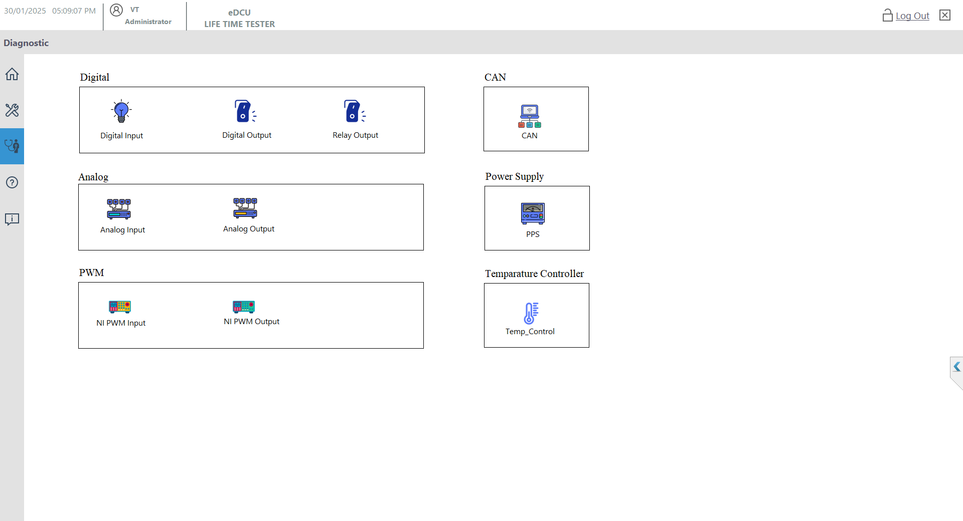
1 showing Popup
2 showing Popup
3 showing Popup
5 showing Popup
4 showing Popup
6 showing Popup
7 showing Popup
8 showing Popup
9
10
1111
12
Figure 45: Diagnostic Test Screen

Digital Input Diagnostic Screen
- Click the Diagnostic Screen Button and Figure 45: Diagnostic Test Screen.
- Click the Digital Input Diagnostic Button and Refer Fig 46.
- Select the Operation for this NI Digital Input Card Selection.
- Click the Start Button use Signal Acquire the Digital Input Signals.
- Show the Digital Input status (ON or OFF).
- If need the stop the acquire the Digital Signal Click Stop Button.
- Finally Click the Close Button.
3 showing Popup
4 showing Popup
5 showing Popup
6
7
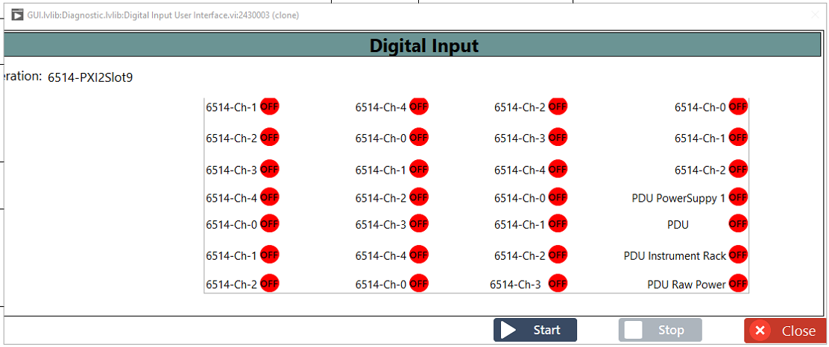

Figure 46: Digital Input

Digital Output Diagnostic Screen
- Click the Diagnostic Screen Button and Figure 45: Diagnostic Test Screen.
- Click the Digital Output Diagnostic Button and Refer Fig 47.
- Select the Operation for this NI Digital Output Card Selection.
- Click the Start Button use Signal Write the Digital Output Signals.
- Enable Digital Output Control (ON or OFF) as needed.
- Click the Write Button
- If need the stop the Control the Digital Signal Click Stop Button.
- Finally Click the Close Button.
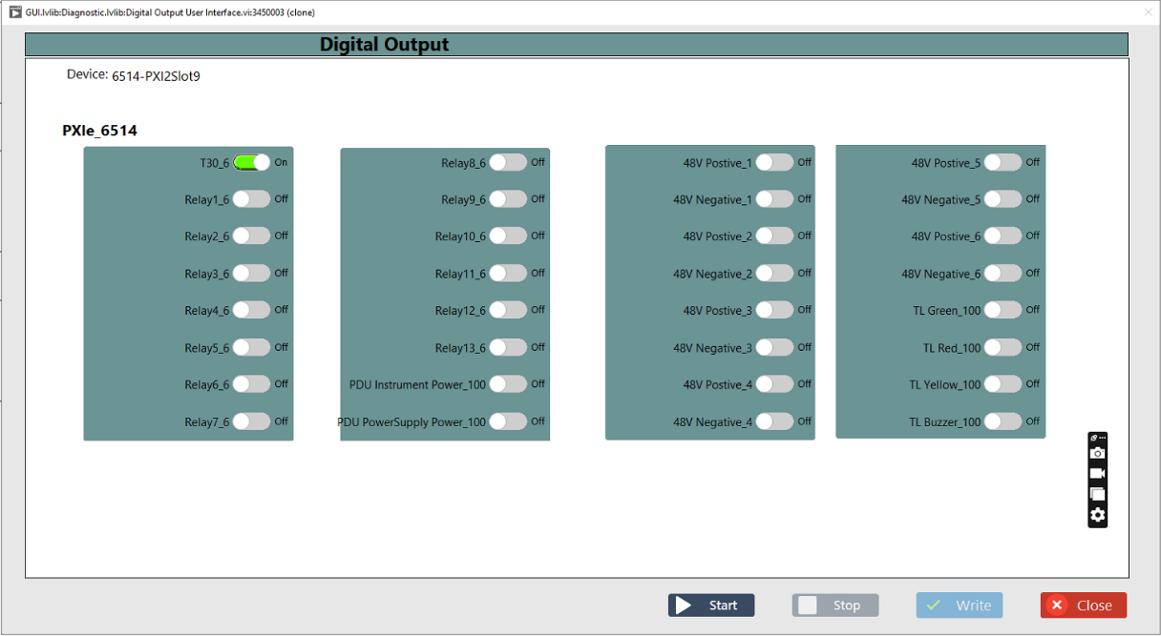
3
4
5
6
7
8
Figure 47: Digital Output

Relay Output Diagnostic Screen
- Click the Diagnostic Screen Button and Figure 45: Diagnostic Test Screen.
- Click the Relay Output Diagnostic Button and Refer Fig 48.
- Select the Operation for this NI Relay Output Card Selection.
- Click the Start Button use Signal Write the Digital Output Signals.
- Enable Digital Output Control (ON or OFF).
- Click the Write Button
- If need the stop the Control the Digital Signal Click Stop Button.
- Finally Click the Close Button.
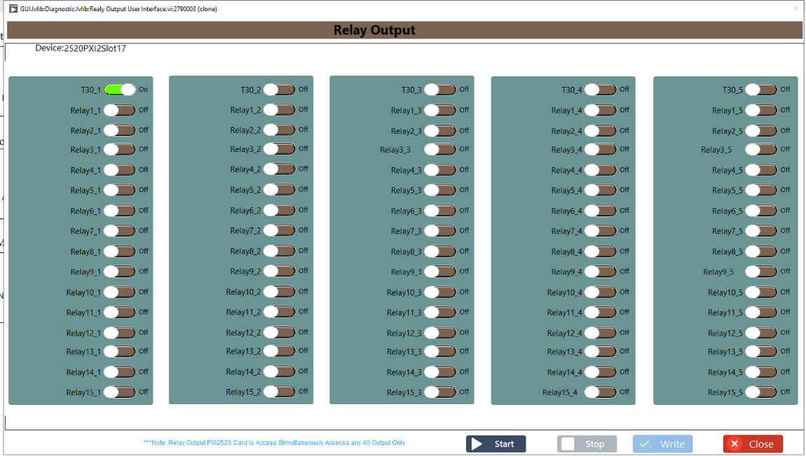
5
4
3
6
7
8
Figure 48: Relay Output

Analog Input Diagnostic Screen
- Click the Diagnostic Screen Button and Figure 45: Diagnostic Test Screen
- Click the Analog Input Diagnostic Button and Refer Fig 49.
- Select the Operation for this NI Analog Input Card Selection.
- Click the Start Button to use Signal Acquire the Analog Input Signals.
- Show the Analog Input Read Data.
- If need the stop the acquire the Analog Signal Click Stop Button.
- Finally Click the Close Button.

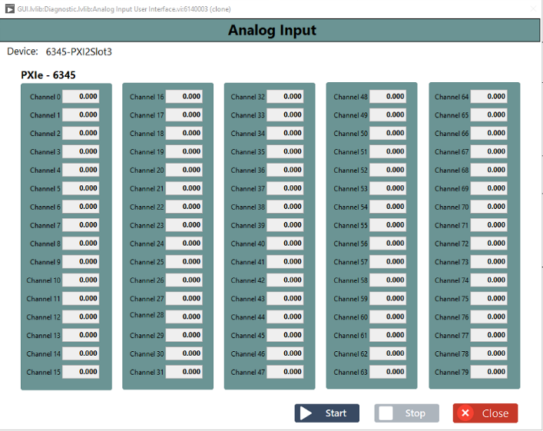
3
5
4
6
7
Figure 49: Analog Input

Analog Output Diagnostics Screen
- Click the Diagnostic Screen Button and Figure 45: Diagnostic Test Screen.
- Click the Analog Output Diagnostic Button and Refer Fig 50.
- Select the Operation for this NI Analog Output Card Selection.
- Click the Start Button to use Signal Write the Analog Output Signals.
- Entry Analog Output Write Data.
- Click the Write Button
- If need the stop the Control the Analog Signal Click Stop Button.
- Finally Click the Close Button.

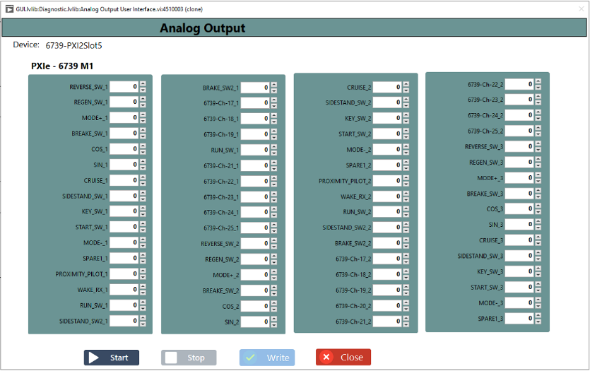
3
5
4
6
7
8
Figure 50: Analog Output

PWM Input Diagnostics Screen
- Click the Diagnostic Screen Button and Figure 45: Diagnostic Test Screen.
- Click the PWM Input Diagnostic Button and Refer Fig 51.
- Select the Operation for this NI PWM Input Card Selection.
- Select the Terminal Configuration.
- Tick the Enable or Disable the Channel.
- Select the Physical Channel.
- Click the Start Button to use Signal Acquire the PWM Input Signals.
- Show the PWM Input Read Data Show the Frequency and Duty Cycles in Max 0.99.
- If need the stop the acquire the PWM Signal Click Stop Button.
- Finally Click the Close Button.

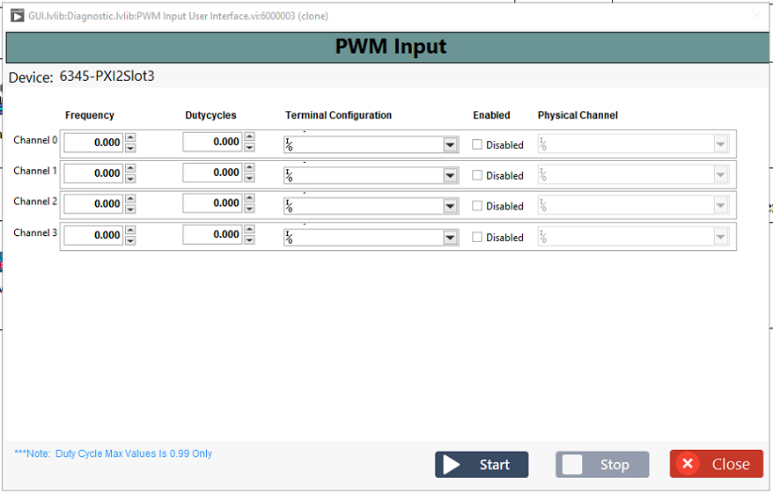
3
8
4
5
6
7
9
10

Figure 51: PWM Input

PWM Output Diagnostics Screen
- Click the Diagnostic Screen Button and Figure 45: Diagnostic Test Screen.
- Click the PWM Output Diagnostic Button and Refer Fig 52.
- Select the Operation for this NI PWM Output Card Selection.
- Select the Terminal Configuration.
- Tick the Enable or Disable the Channel.
- Select the Physical Channel.
- Enter the Channel Frequency and Duty Cycles (0.99 Max).
- Click the Start Button for Signal Write the PWM Output Signals
- If need the stop the Write the PWM Signal Click Stop Button.
- Finally Click the Close Button.

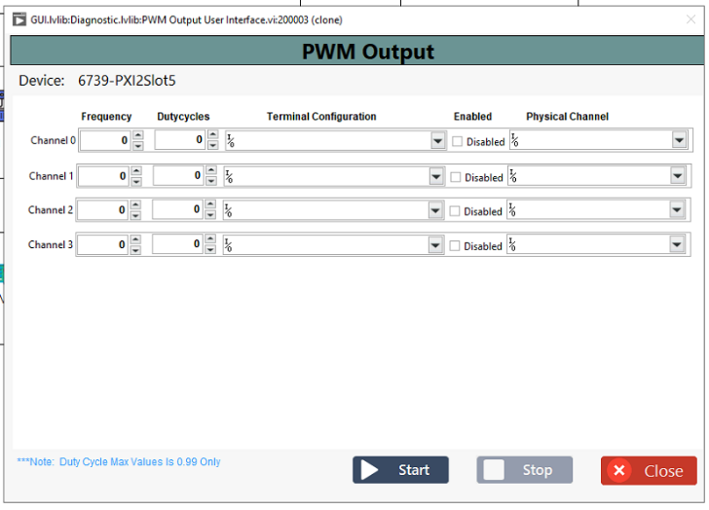
3
5
4
6
7
8
9
10

Figure 52: PWM Output

CAN Diagnostics Screen
- Click the Diagnostic Screen Button and Figure 45: Diagnostic Test Screen.
- Click the CAN Diagnostic Button and Refer Fig 53.
- Click the Configuration Tab button.
- Select the XNET Interface CAN port for Ex CAN2 (Socket 0) and CAN4 (Socket 1).

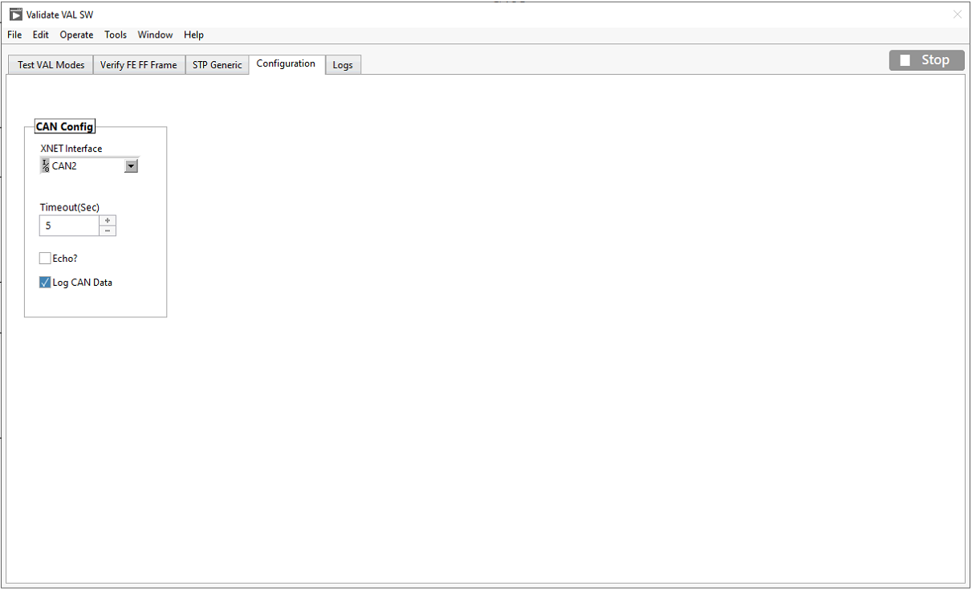
3
4
Figure 53: CAN Configuration

Check VAL Software and Mode Testing
- Click the Diagnostic Screen Button and Figure 45: Diagnostic Test Screen.
- Click the CAN Diagnostic Button and Refer Fig 53.
- Configure the CAN Channel and Refer Fig 54.
- Click the Test VAL Modes Tab Control button.
- Click the TSW version button.
- Show the TSW version.
- Click the VAL SW Version button.
- Show the VAL SW Version.
- Select the VAL Mode.
- Click the Start button and Mode is running.
- Click the Start button and Mode is Stop.
- Click the Latest RMS Current button.
- Show the Latest RMS Current Data.
- Show the CAN Read Raw Data.
- Show the Response Status.
- Finaly Click the Stop button.
4
5
6
7
8
9
10
11
12
13
14
15
16
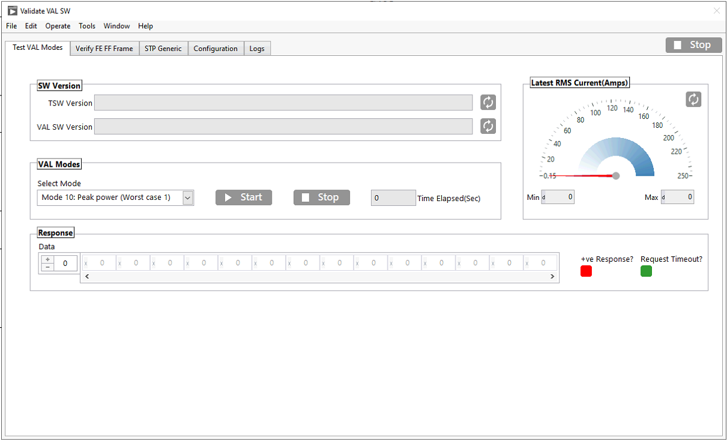
Figure 54: Test Software and Mode Write and eDCU Response Read

Read FE FF Frames Data
- Click the Diagnostic Screen Button and Figure 45: Diagnostic Test Screen.
- Click the CAN Diagnostic Button and Refer Fig 53.
- Configure the CAN Channel and Refer Fig 55.
- Click the Verify FE FF Frame Tab Control button.
- Select the Frame Type and FE Frame or FF Frame.
- Select the Data Source.
- Enable or Disable the Raw Data.
- Click the Refresh button.
- Show Data Size.
- Show the Response Status.
- Show the Frame Data.
- Finally Click the Stop button.
4
5
11
6
8
7
5
12
10
9
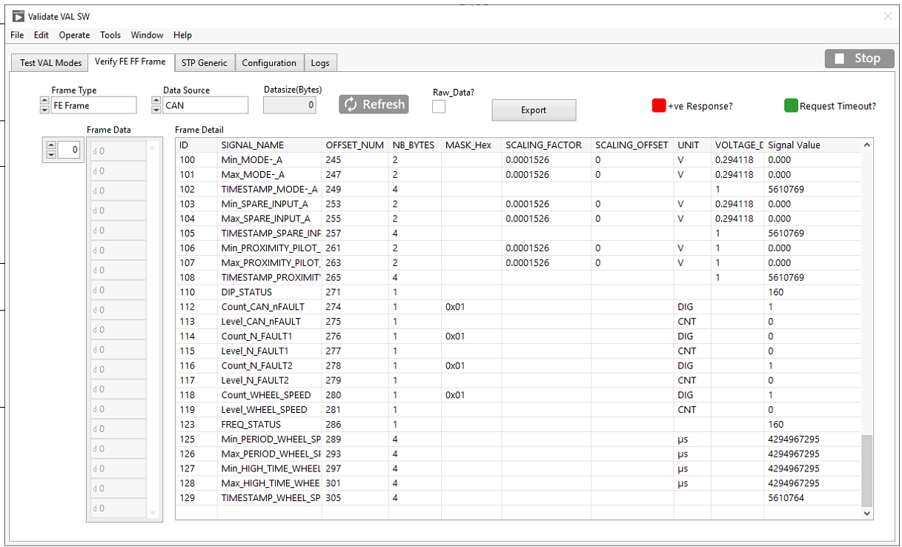
Figure 55: CAN Verify FE FF Frame Read

CAN STP Generic Request/Response
- Click the Diagnostic Screen Button and Figure 45: Diagnostic Test Screen.
- Click the CAN Diagnostic Button and Refer Fig 53.
- Configure the CAN Channel and Refer Fig 56.
- Select the Command.
- Enter Valid Write Data.
- Click the Sent button.
- Show the Response Data (Hex).
- Show the Response Data (ASCII).
- Show the Response Status.
- Finally Click the Stop button.

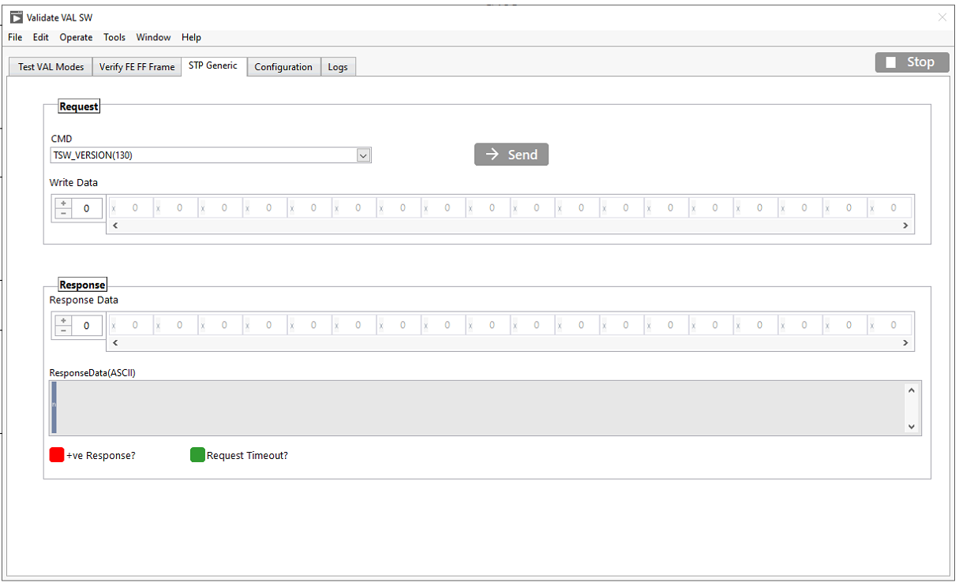
4
5
7
6
8
9
10
11
Figure 56: CAN STP Generic Read

Monitor CAN Log
- Click the Diagnostic Screen Button and Figure 45: Diagnostic Test Screen.
- Click the CAN Diagnostic Button and Refer Fig 57.
- Click the Log Tab Control button.
- Show the CAN View Table for Verify the CAN Read and Write Data.
- Finally Click the Stop button.
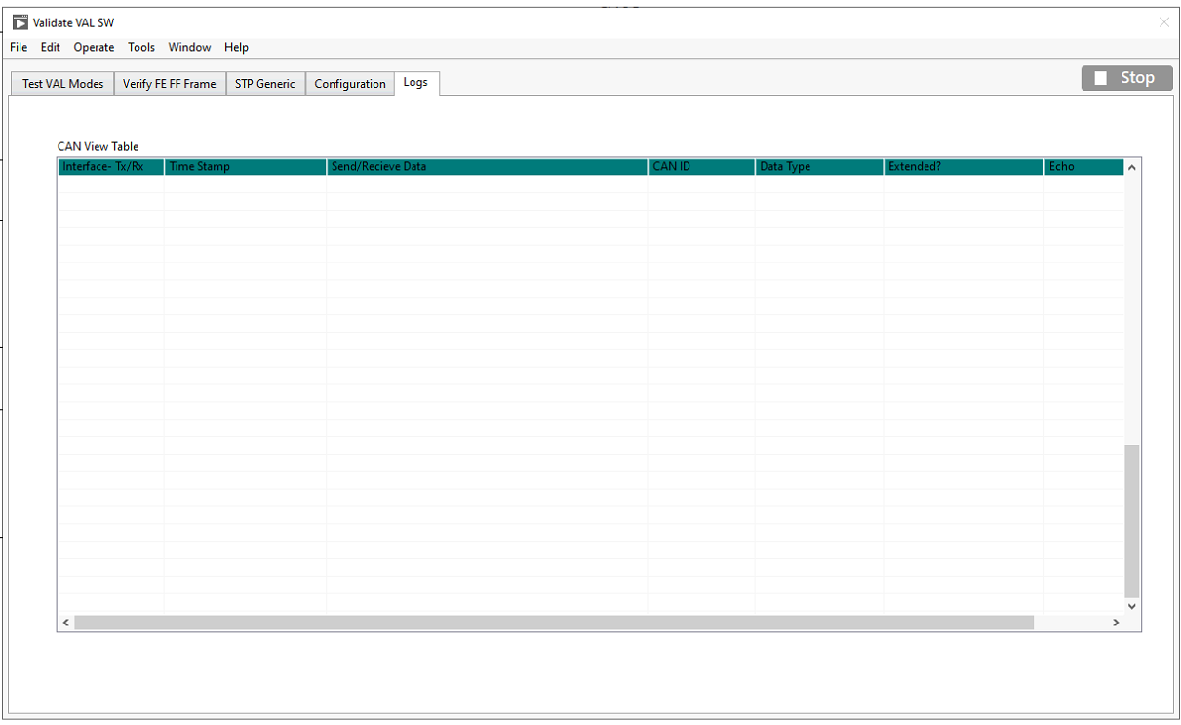
3
4
5
Figure 57: CAN Log Read

High Voltage PPS Diagnostic Screen
- Click the Diagnostic Screen Button and Figure 45: Diagnostic Test Screen.
- Click the PPS Diagnostic Button and Figure 45: Diagnostic Test Screen.

HV PPS Initialization

- Select the Operation “Init”.
- Select the HVPPS Based socket Number
- Click the Apply.
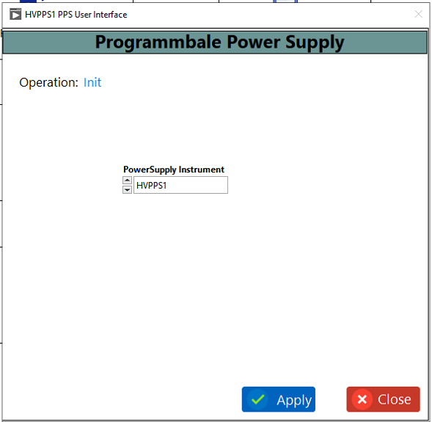
3
4
5

Figure 58: HV PPS Initialize

HV PPS Self-test
- Click the Diagnostic Screen Button and Figure 45: Diagnostic Test Screen.
- Click the PPS Diagnostic Button and Figure 45: Diagnostic Test Screen.
- Click the PPS Init and Refer Fig 58.
- Select the Operation “Self-Test”.
- Click the Apply.
- Show the Power supply Status

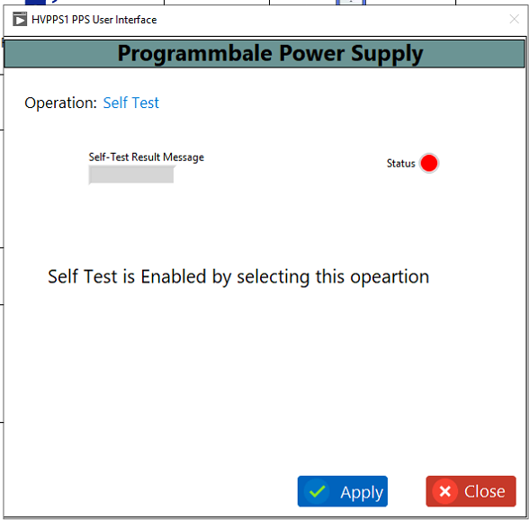
4
5
6

Figure 59: HV PPS Self-Test

HV PPS Configure
- Click the Diagnostic Screen Button and Figure 45: Diagnostic Test Screen.
- Click the PPS Diagnostic Button and Figure 45: Diagnostic Test Screen.
- Click the PPS Init and Refer Fig 58.
- Select the Operation “Configure”.
- Pre-Configure the Data for based on Power supply Selection.
- Enable or Disable the Output.
- Click the Apply.
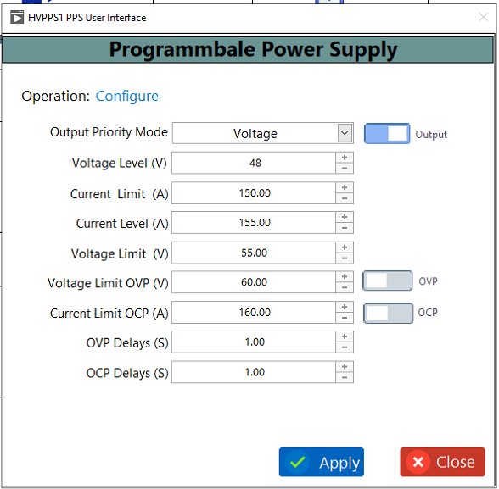
4
5
6
7

Figure 60: HV PPS Configure

HV PPS Measure Current
- Click the Diagnostic Screen Button and Figure 45: Diagnostic Test Screen.
- Click the PPS Diagnostic Button and Figure 45: Diagnostic Test Screen.
- Click the PPS Init and Refer Fig 58.
- Select the Operation “Measure Current”.
- Show the Measure Current Data.
- Click the Apply.
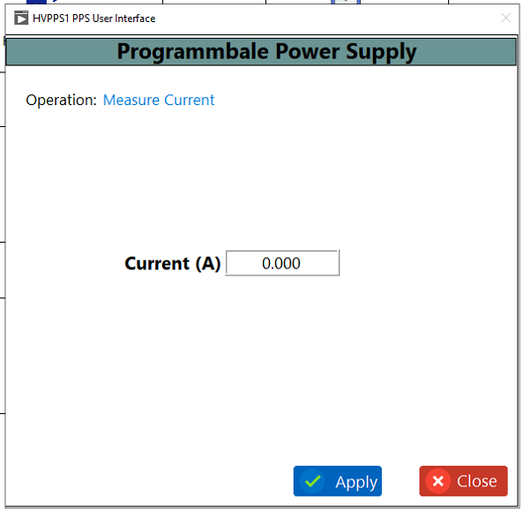
4
5
6
Figure 61: HV PPS Measure Current

HV PPS Close
- Click the Diagnostic Screen Button and Figure 45: Diagnostic Test Screen.
- Click the PPS Diagnostic Button and Figure 45: Diagnostic Test Screen.
- Click the PPS Init and Refer Fig 58.
- Select the Operation “Close”.
- Click the Apply
- Finally Click the Close Button.
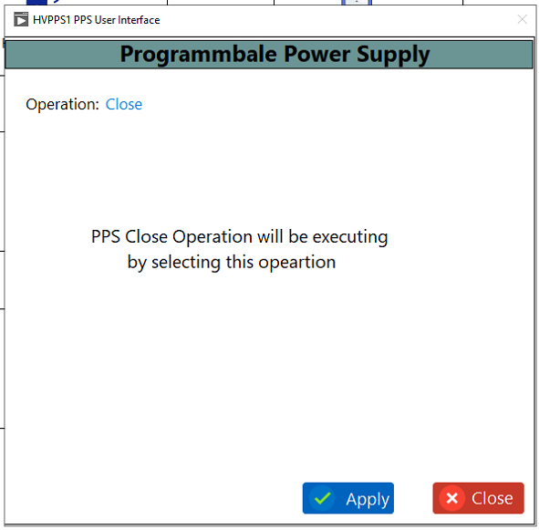
4
5
6
Figure 62: HV PPS Close

Procedure LV PPS Diagnostic Screen
- Click the Diagnostic Screen Button and Figure 45: Diagnostic Test Screen.
- Click the PPS Diagnostic Button and Figure 45: Diagnostic Test Screen.

LV PPS Initialization

- Select the Operation “Init”.
- Select the LVPPS
- Click the Apply.
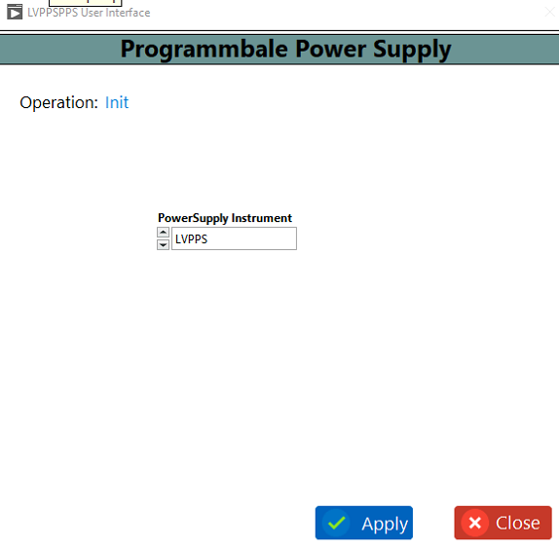
3
4
5
Figure 63: LV PPS Initialize

Procedure LV PPS Self-test
- Click the Diagnostic Screen Button and Figure 45: Diagnostic Test Screen.
- Click the PPS Diagnostic Button and Figure 45: Diagnostic Test Screen.
- Click the PPS Init and Refer Fig 63.
- Select the Operation “Self-Test”.
- Click the Apply.
- Show the Power supply Status
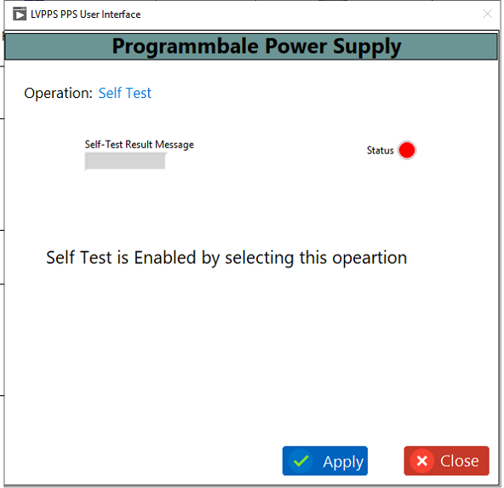
4
5
6
Figure 64: LV PPS Self-Test

Procedure LV PPS Configure
- Click the Diagnostic Screen Button and Figure 45: Diagnostic Test Screen.
- Click the PPS Diagnostic Button and Figure 45: Diagnostic Test Screen.
- Click the PPS Init and Refer Fig 63.
- Select the Operation “Configure”.
- Pre-Configure the Data for based on Power supply Selection.
- Enable or Disable the Output.
- Click the Apply.
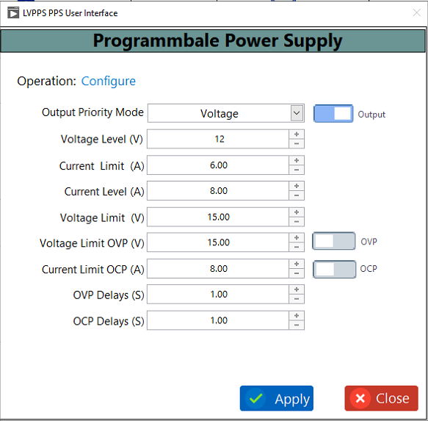
4
5
6
7
Figure 65: LV PPS Configure

Procedure Configure LV PPS Measure Current
- Click the Diagnostic Screen Button and Figure 45: Diagnostic Test Screen.
- Click the PPS Diagnostic Button and Figure 45: Diagnostic Test Screen.
- Click the PPS Init and Refer Fig 63.
- Select the Operation “Measure Current”.
- Show the Measure Current Data.
- Click the Apply.
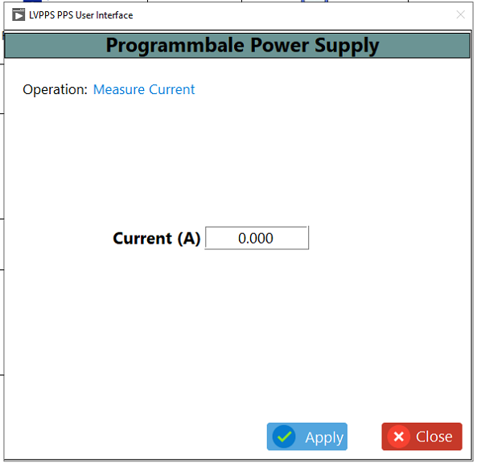
4
5
6
Figure 66: LV PPS Measure Current

Procedure LV PPS Close
- Click the Diagnostic Screen Button and Figure 45: Diagnostic Test Screen.
- Click the PPS Diagnostic Button and Refer Fig 58.
- Click the PPS Init and Refer Fig 63.
- Select the Operation “Close”.
- Click the Apply
- Finally Click the Close Button.
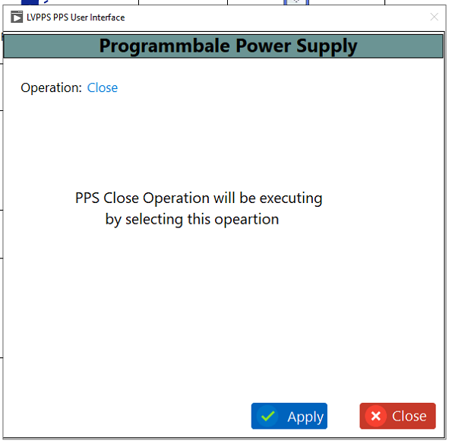
4
5
6
Figure 67: LV PPS Close

Temperature Diagnostic Screen
In this Screen we can Diagnostic power supply Temperature, Chamber Temperature, Load rack Temperature. We can read or write the Temperature Controller.
- Click the Diagnostic Screen Button and Figure 45: Diagnostic Test Screen.
- Click the Temperature controller and Figure 45: Diagnostic Test Screen.
- Select the Operation in Read or Write.
- Select the Slave Unit ID.
- If Operation is “Written” and Enter the Write Starting Address.
- If Operation is “Writing” Enter the Set Limit Temperature.
- Click the Apply button.
- If Operation is “Read” and Enter the Read Starting Address, Number of Holding.
- Click the Apply button.
- If Operation is “Read” Show the Holding Registers Value.
- Show the Current Temperature and Set Limit Temperature.
- Finally Click the Close button.
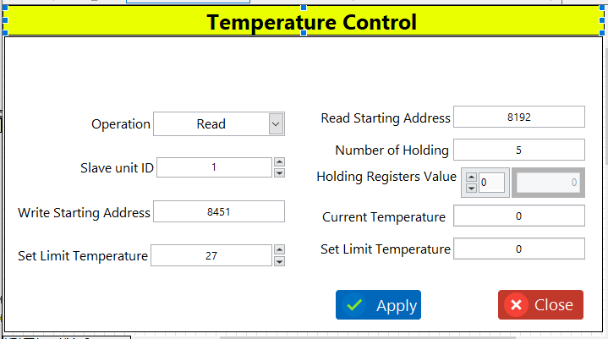
1
2
3
4
5&7
6
8
9
10

Figure 68: Temperature control

Procedure for Flashing of VAL Software to DUT

This section outlines the process for flashing the TSW+VAL software to the DUT. There are two methods available: the Manual procedure or the Automated procedure.

Setup
- Launch the LTT Application (refer: How to Launch LTT Application)
- Please refer to the procedure for the manual mode steps in the for Procedure for Manually Flashing of VAL Software to DUT.
- Please refer to the procedure for the auto mode steps in the for Procedure for Automated Flashing of VAL Software to DUT.
- ……..add other steps and give reference

Procedure for Manually Flashing of VAL Software to DUT
Click the Diagnosis button to display the screen. To use flashing, access the driver programmable power supply and digital output. The user screen, as shown below, will appear. Please refer to Fig. 69.
- We need to Connect the Power Cable(48V) and Connect the Signal Cable to eDCU.
Mention about the breakout box connection here
- Click the Diagnosis symbol button.
- Click the PPS button for HVPPS.
- Click the Digital Output Purpose for HV Power Output Enable and Disable.
- Click the PPS button for LVPPS.
- Click the Relay Output Purpose for LV Power Output Enable and Disable.
- Click the CAN button Purpose for Check eDCU SW version

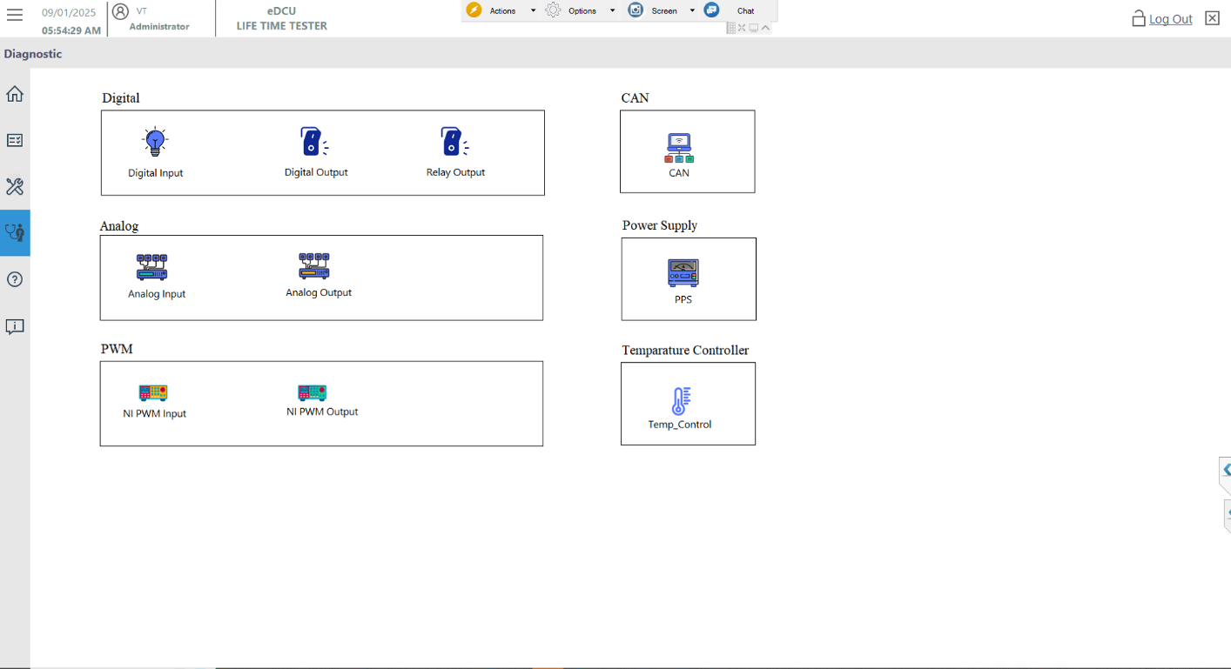
2
3&5
4
6
7
Figure 69: Diagnosis mode Flash

Procedure of DUT Power ON.
- Pre-Power Check.
- Before powering on the system, inspect all connections for correct placement and secure engagement.
- Switch and Power Supply Status Turn Off Condition.
  - Confirm that all DO switches and are OFF before applying power.
  - Ensure the power supply is set to the correct voltage and current settings for the DUT.
  - Inspect for any potential short circuits or incorrect wiring that may cause issues when power is applied.
- DUT Connection.
- Ensure the DUT is Positive and Negative Connection and Load side U, V, W Connection then 40 Pin Connection Connected.
- Confirm there are no loose components or connections on the DUT.
- Fixture Engagement.
- Verify that the DUT is properly engaged with the Harting Connection.
- Verify the Harting Connector connected to the LTT Side.
- Check the Connector for any mechanical or alignment issues that may cause improper contact.
- Connections for Manual Test.
40-pin Connector:
- Verify the 40-pin connector is properly seated and locked in place.
UVW Cables.
- Check that the UVW cables (U, V, W phases) are correctly connected, ensuring proper phase alignment.
DC Link Cables.
- Ensure that the DC link cables are connected securely without loose terminals or exposed wires.

Turn ON Power Supply (T30 and DC Link)
Click the PPS button and Selection list mention LVPPS, HVPPS (Based the socket selection HVPPS) the Run Cleanup and tick the Don’t show again batch execution then click the OK. screen below the user screen will appear Refer the Fig 69.
- Click the Diagnostic Screen Button and Refer Fig 69.
- Select the Operation “Init”.
- Select the power supply for LVPPS or HVPPS based on Socket and Ensure the Hardware Connection.
- Click the apply button.

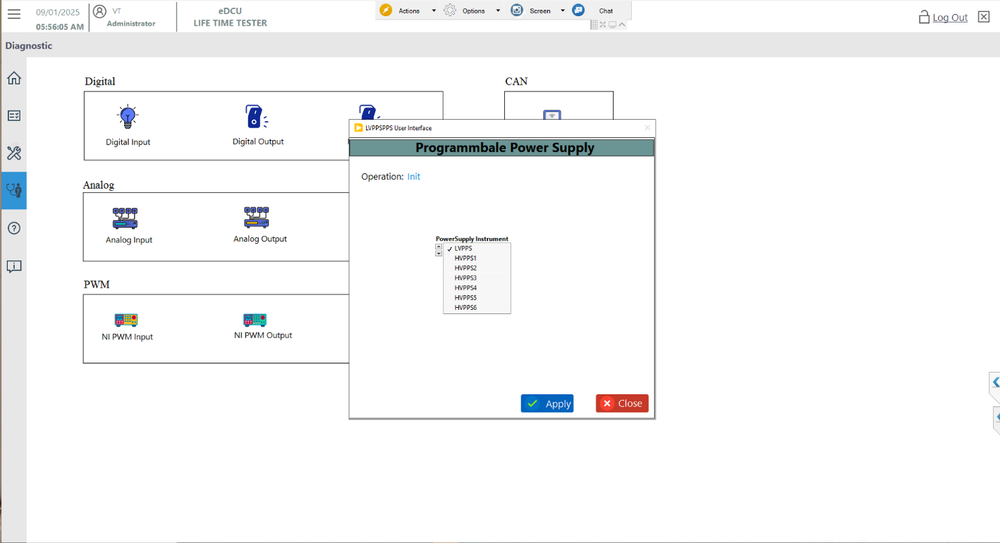
1
2
3
Figure 70: Power Supply Selection

High Voltage PPS Initialize
HVPPS initialize the instrument then click the Apply. screen below the user screen will appear.
- Click the Diagnostic Screen Button and Refer Fig 69
- Select the Operation “Init”.
- Select the PPS Selection HVPPS (Based Socket 0 Ex: - HVPPS1).
- Final Click the Apply Button.
- Title bar reflected on selected PPS to Verify
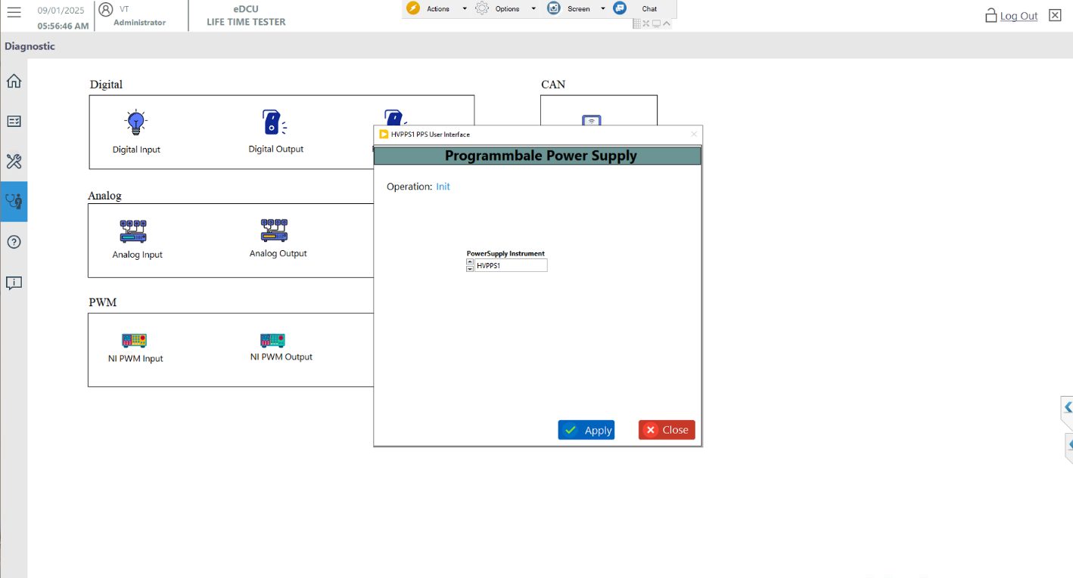
1
2
3
4
Figure 71: HV PPS Initialize

High Voltage PPS Configure
HVPPS Pre configuration and Enable the Output Only to click the OK. screen below the user screen will appear.
    - Click the Diagnostic Screen Button and Refer Fig 69
    - Select the Operation “Configure”
    - Based on power supply selection Data is Preconfigured
    - Configure the Enable Output Button.
    - Final Click the Apply Button.

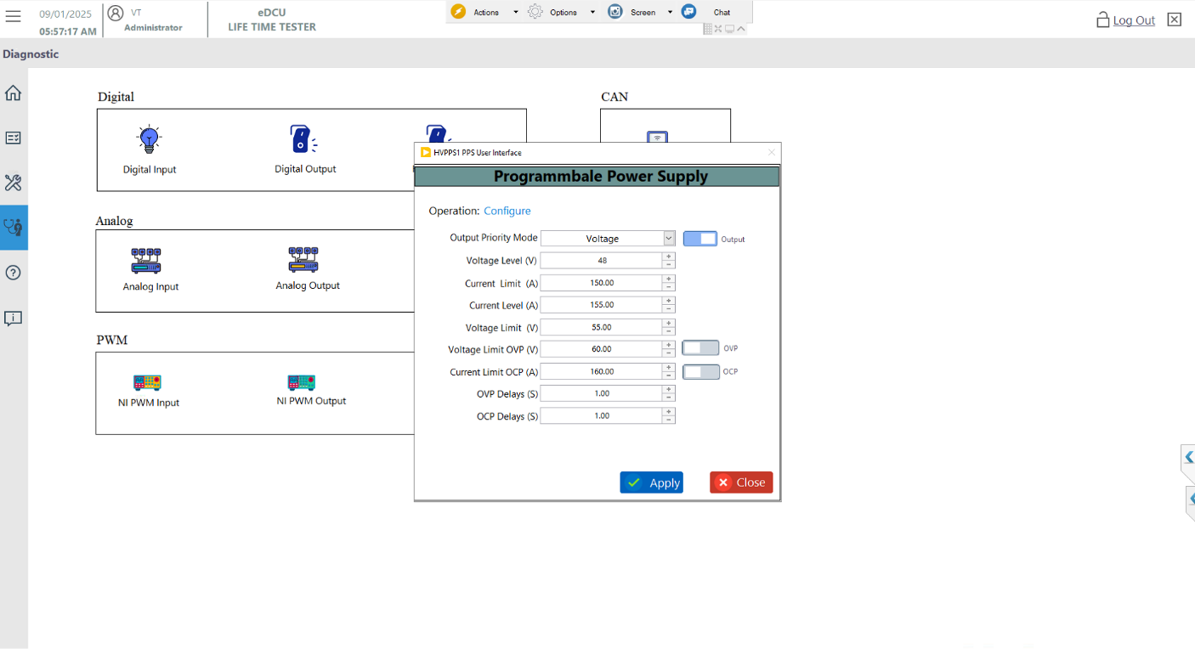
1
2
3
4
Figure 72: HV PPS Configure

Turn ON High Voltage PPS Digital Output(Relay)
eDCU 48V Positive and Negative Digital Output Enabled and Write. screen below the user screen will appear.
- Click the Diagnostic Screen Button and Refer Fig 69
- Enable the 48V Positive and Negative Output Based on Socket.
- Click the Start Button.
- Finally Click the Write Button.
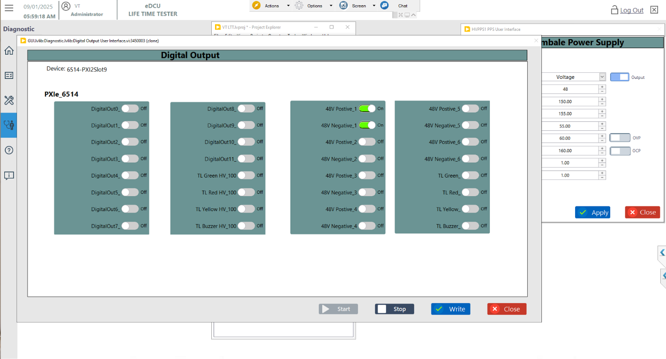
1
2
3

Figure 73: HV PPS Relay Output

Low Voltage PPS Initialize
LVPPS initialize the instrument then click the Apply. screen below the user screen will appear.
- Click the Diagnostic Screen Button and Refer Fig 69
- Select the Operation “Init”
- Select the PPS Selection LVPPS.
- Final Click the Apply Button.
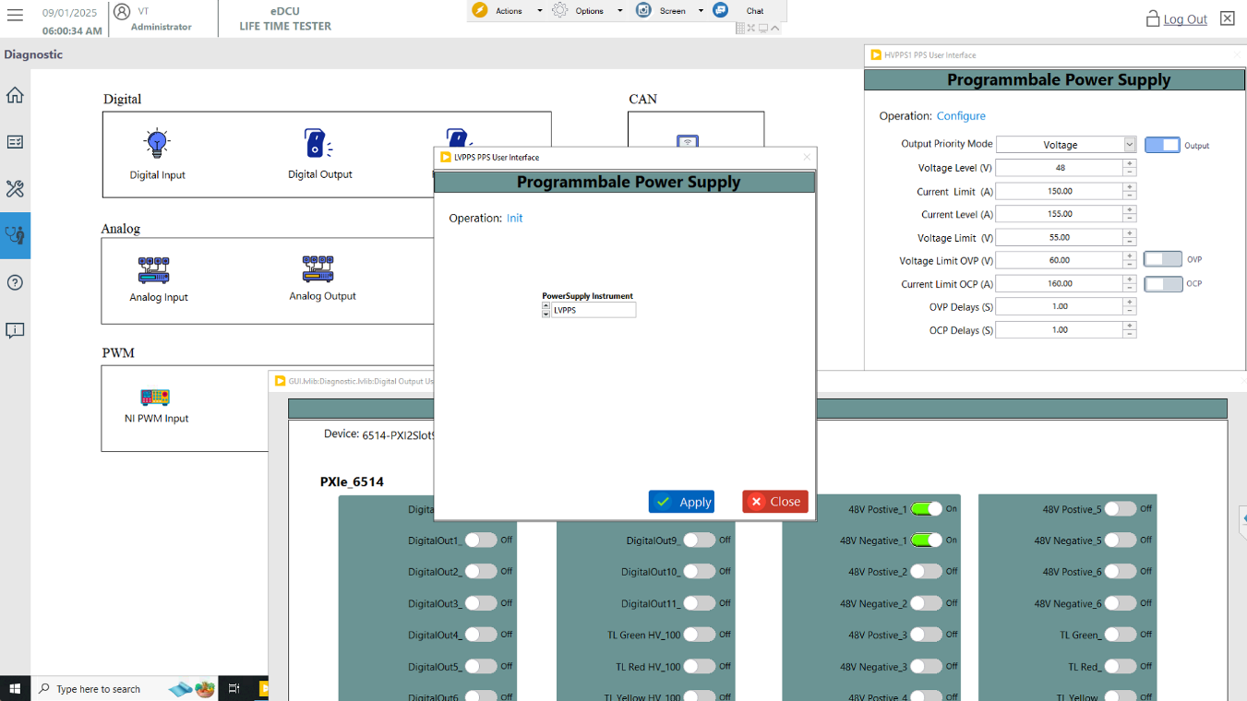
2
1
3

Figure 74: LV PPS Initialize

Low Voltage PPS Configure
LVPPS Pre configuration and Enable the Output Only to click the OK. screen below the user screen will appear.
- Click the Diagnostic Screen Button and Refer Fig 69
- Select the Operation “Configure”.
- Based PPS Selection Configure the Data.
- Configure the Enable Output Button.
- Final Click the Apply Button.

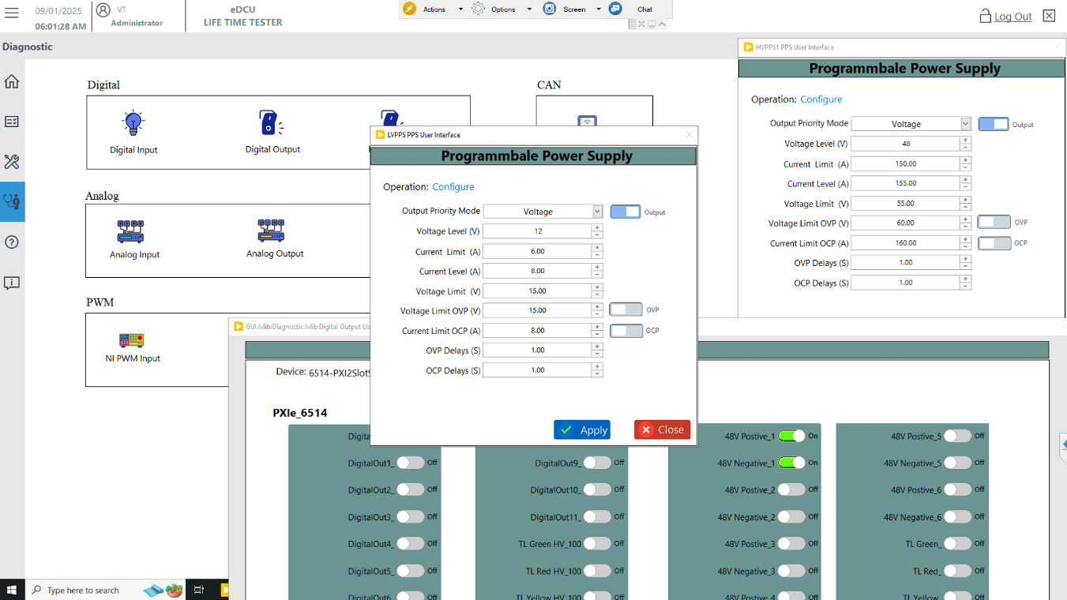
1
4
3
2

Figure 75: LV PPS Configure

Turn ON Low Voltage PPS Relay Output
eDCU 12V Positive and Negative Relay Output Enabled and Write. screen below the user screen will appear.
- Click the Diagnostic Screen Button and Refer Fig 69
- Enable the 12V T30 and T30 GND Output.
- Click the Start Button.
- Finally Click the Write Button.

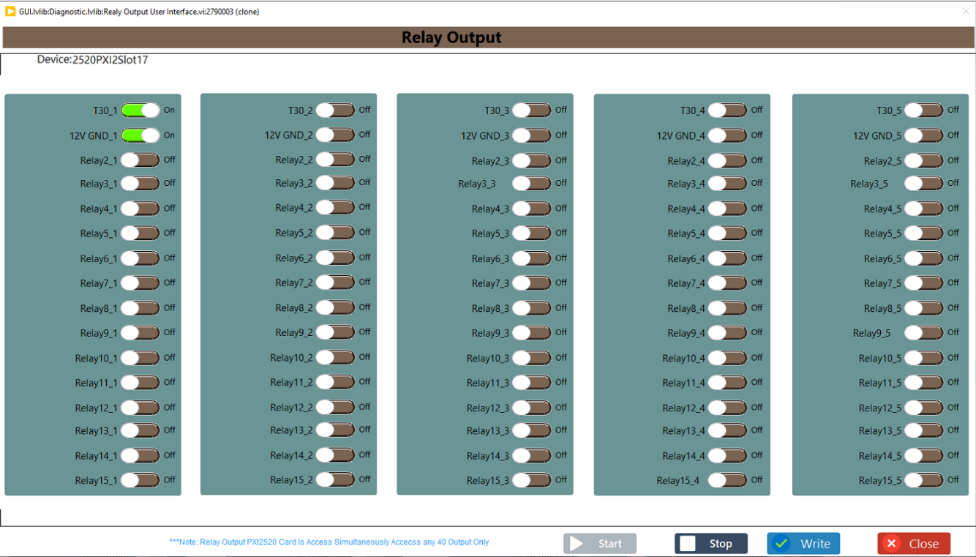
1
3
2

Figure 76: LV PPS Relay Output

CAN Configure
CAN configure the port based on socket. screen below the user screen will appear.
- Click the Diagnostic Screen Button and Refer Fig 69
- Click the Tab Configure
- Based Socket CAN port selection (Ex: Socket0-CAN2, Socket1-CAN4)
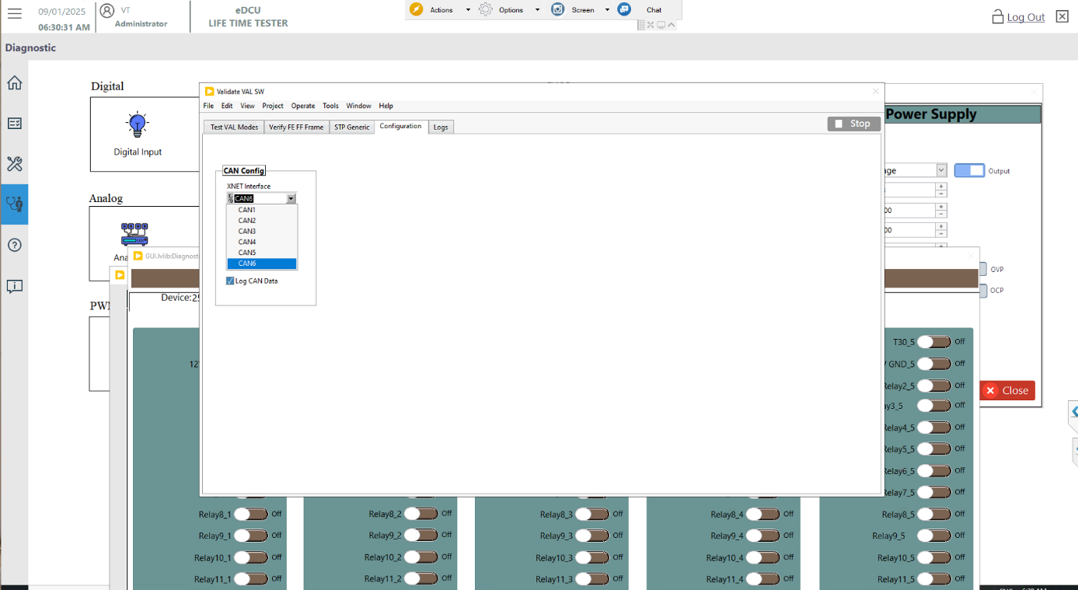
1
2

Figure 77: CAN Configuration

Read SW Version
Click the CAN Read the VAL SW the read. screen below the user screen will appear.
- Click the Diagnostic Screen Button and Refer Fig 69
- Click the Tab Test VAL Modes Button
- Click the Button TSW version read
- Show the TSW version
- Click the Button VAL version read
- Show the VAL version

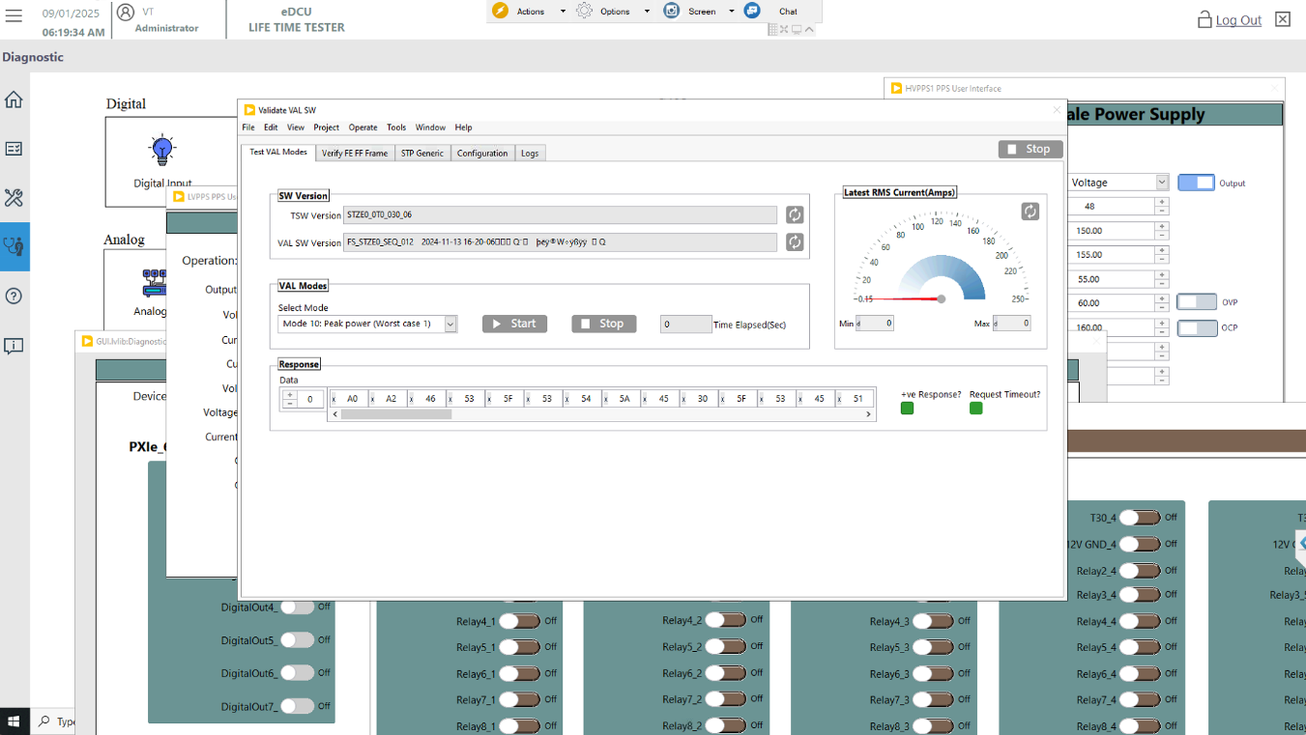
1
2
3
4
5

Figure 78: CAN Test VAL Modes

Flashing New Software
After using the flashing tool and completing the flashing process, power was turned off on the eDCU. After 10 seconds, the eDCU was powered on again.

Verify Updated SW after Flash
Once the eDCU is powered on, the TSW version and VAL SW version need to be read and compared to the flashing version for verification.

Procedure for Automated Flashing of VAL Software to DUT
Please refer to the procedure in the page/section for further details. Procedure for Auto Mode (To Start New/Existing Test)

Run the Software Flash Sequence
Select open the sequence File Path and the Software Flashing Sequence display the windows then Start the Test. “Running Display” screen below the user screen will appear and Refer the Figure 24.
- Click the Open Sequence button and Select the Sequence file Location is
D:\eDCU LTT\VT LTT Project\Client Sequence\eDCU\Software Flash.seq
- Show the Selected Sequence file was loaded.
- Click the Start the Button.
- Flow the Figure Next Steps.

1
2
3
Figure 79: How to Flash Sequence

Read existing software
- Existing Software read TSW and VAL SW Version showing Popup
- Click the button “OK”.
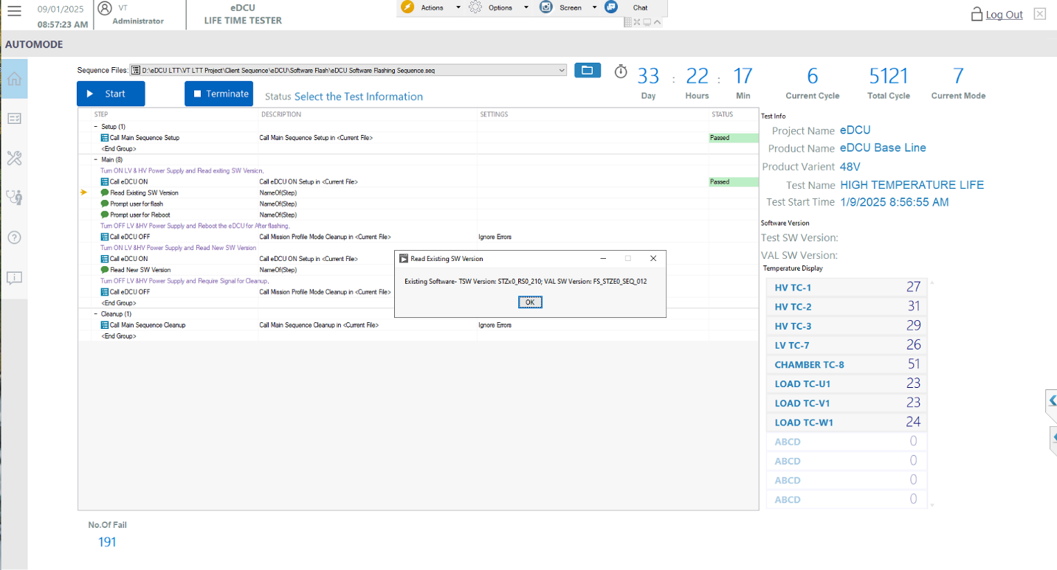
1
2
Figure 80: Existing Software version Read

Flashing New Software
- Proceed the flash the eDCU and After flashing showing Popup.
- click the “OK” Button.
.
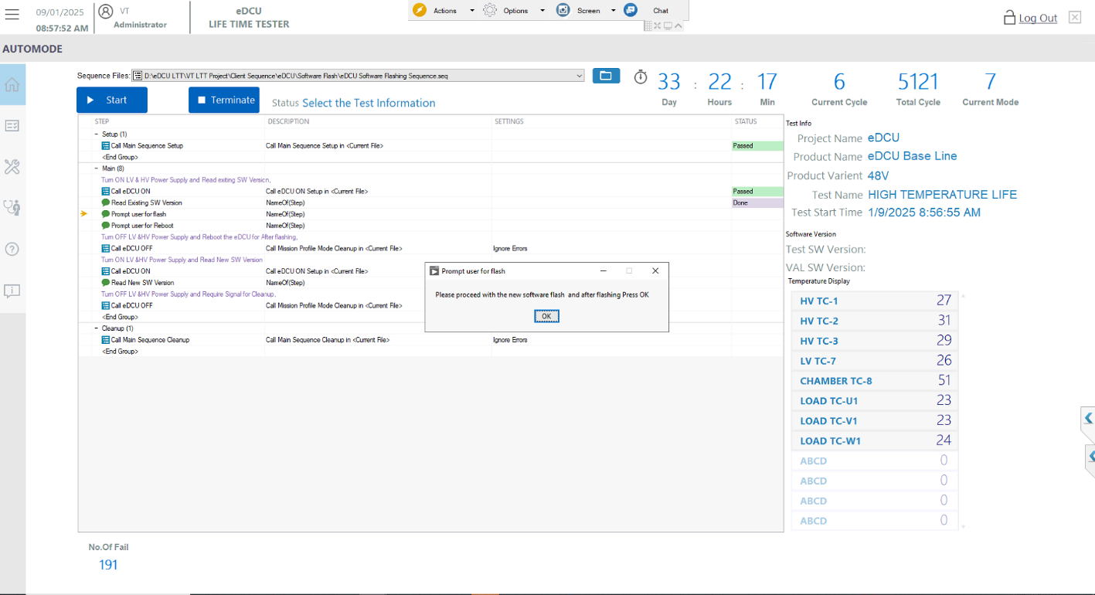
1
2

Figure 81: Proceed Flash the Software

Reboot DUT
- Proceed with the reboot the eDCU and showing Popup
- click the “OK”.

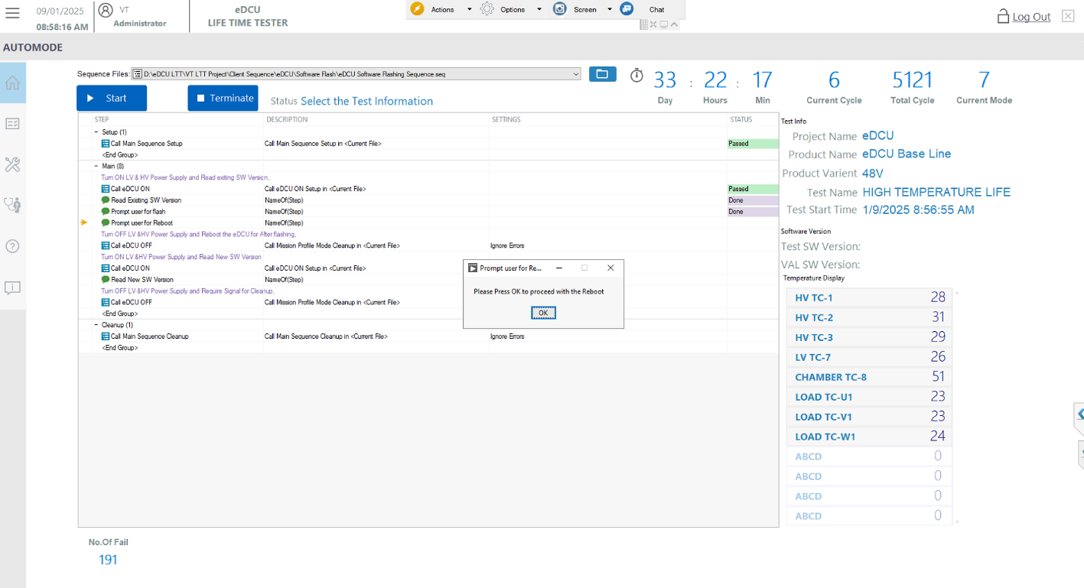
1 showing Popup
2

Figure 82: Reboot the Test

Verify New Software
- New Software read TSW and VAL SW Version showing Popup and
- Click the button “OK”.

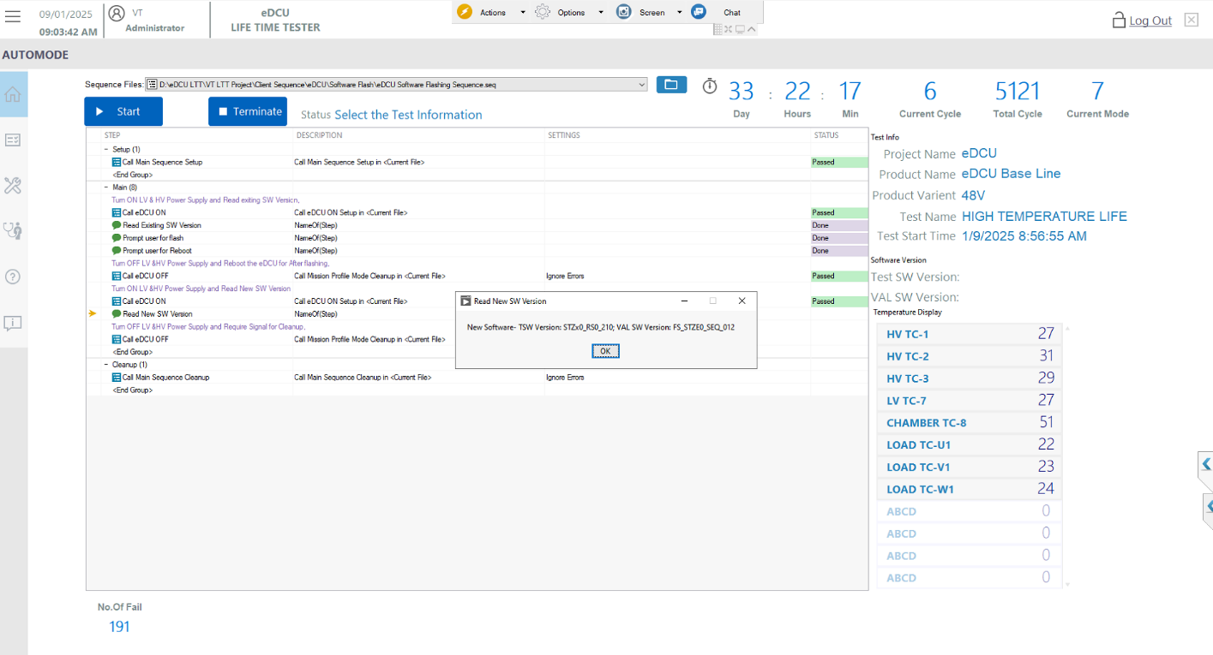
1 showing Popup
2 showing Popup

Figure 83: New Software Version Read

